REPORT ON TWO DAY STUDENT WORKSHOP ON DESIGN THINKING
Date: 5TH & 6TH April, 2025. | Venue: Conference hall, Workshop Hall  and Seminar hall
Time: 9 am to 5.30 pm | Event : Certification Course
No. of Participants: 180 | Event Coordinators:  Section A :  Dr. Tamizharasi  Coordinators: Prof. Pooja .  Section B:  Dr. Purushottam Bung  Prof. Sowmya and Dr. Vinay  Coordinators:  Section C:  Dr. Sumera Aluru  Coordinators: Prof. Ankita and Prof. Uma.

Workshop Schedule
Day 1: (05.05.2025):
9am to 10.30 am- Introduction to Design Thinking and Session on Step 1- Empathize.

10.30 to 11.15am- Activity on Empathize.

11.30am to 11.45am Discussion on the result of the First activity

11.50am to 1.00 pm- Delivery of Step 2- Defining problem statement

1.00pm to 1.30pm- Activity to define problem statement

1.30pm to 1.45pm - Discussion on the outcome of step 2

1.45pm to 2.15pm- Lunch break

2.30 pm to 3.30 pm- Step 3 Ideate

3.30 pm to 4.15pm - Activity on Ideation

4.15pm to 5pm - Discussion on outcome of step 3.
DAY 2 (06.05.2025):
9am to 10.00 am- Presentation on Ideation step

10.00 to 11.00am- Session on Prototyping.

11.00am to 12.30pm- Prototyping

12.30 pm to 1.30 pm- Presentation of the Prototype

1.30pm to 2.00pm- Lunch break

2.00pm to 2.30pm - Session on Testing

2.30pm to 3.30pm- Presentation of Final Model

3.30 pm to 5 pm- Final Presentation and Valedictory.

Conclusion
The two-day design thinking workshop at RVIM was a resounding success, providing students with valuable skills and experiences that will be beneficial in their academic and professional lives. The interactive and practical approach ensured active participation and a deeper understanding of design thinking principles. The workshop has set a strong foundation for future events, with students expressing eagerness for more such interactive learning experiences.
On 6.05.2025, Final Presentation and Valedictory ceremony was conducted where Dr. Purushottam Bung announced the winning teams in each section and awarded them with Cash Prize of Rs.5000 per team and certificates of Excellence.

PHOTO GALLERY:
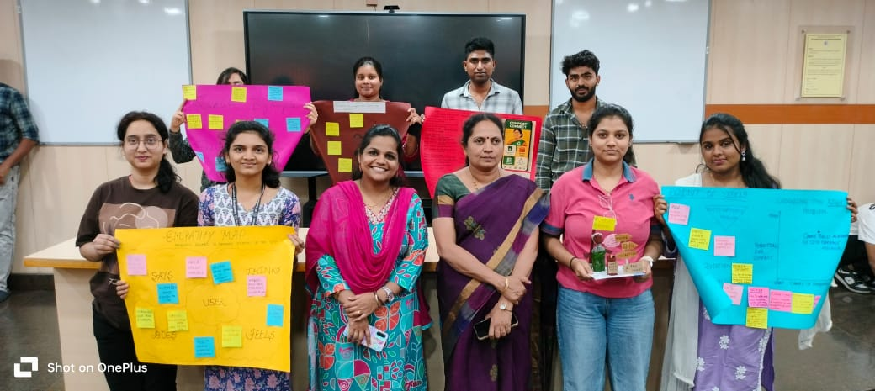 | 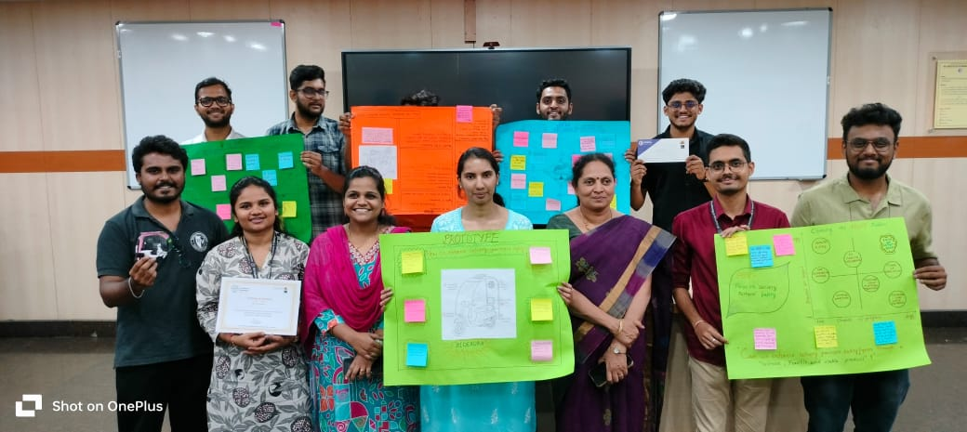
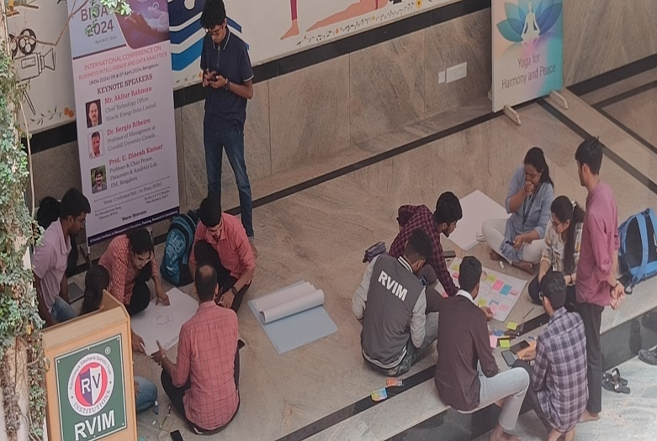 | 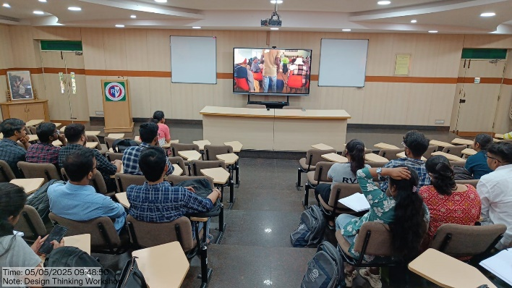
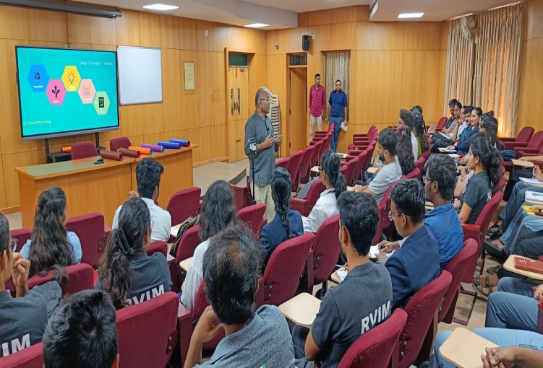 | 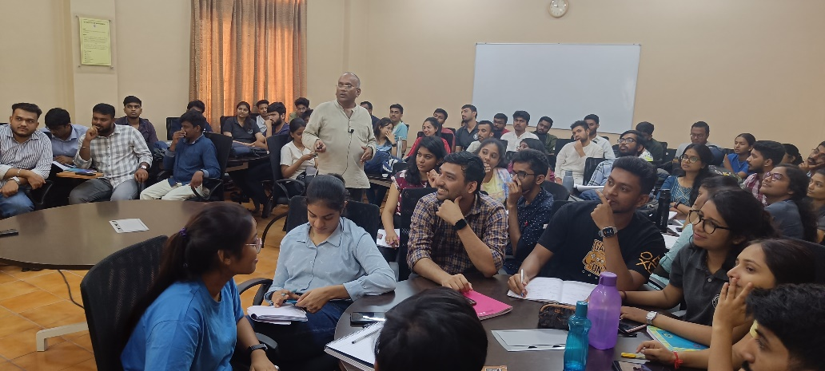
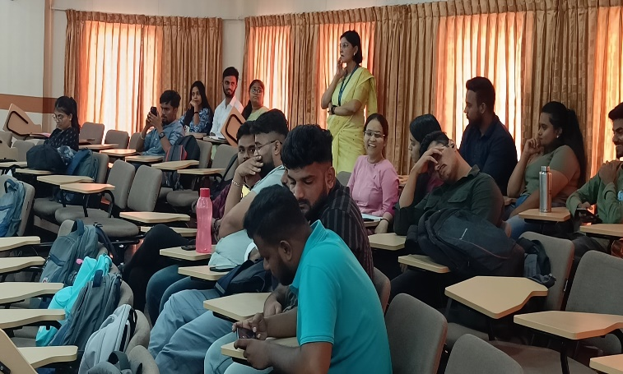 | 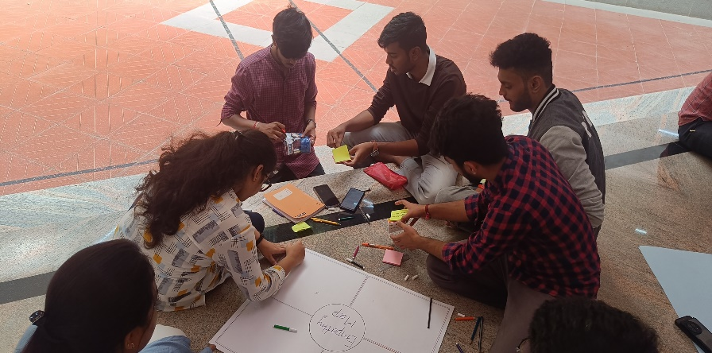


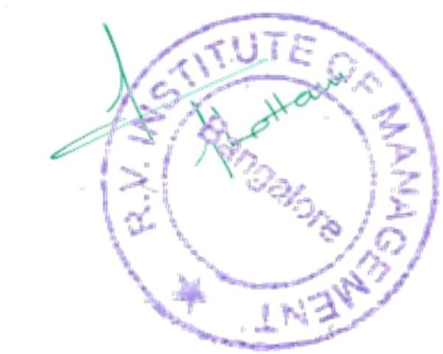




CA 17, 36th Cross Rd, 26th Main, 4th T Block East
Bengaluru - 560041, Karnataka, India
080 42540300
080 26547048
www.rvim.edu.in
Scan Here

Co-ordinator Director

