Report on Certification Course on Auditing

Date: 9th July, 2024 to 25^{h} July, 2024. | Venue: IT Lab, RVIM, Bangalore.
Time: 4.30 pm to 5.30 pm | Event : Certification Course
No. of Participants: 80 | Event Coordinators: Prof: Payal Jindal, Ms. Lakshmi S., Prof. Pooja Takalkar.
The Department of Placements, RVIM conducted a Certification Course on Auditing especially for the students willing to go into the Finance Domain in their 3rd Semester. The course commenced from 9th July, 2024 and ended on 25h July, 2024. The course timings were 4.30 pm to 5.30 pm everyday.
Prof. Payal Jindal, Ms. Lakshmi S. and Prof. Pooja Takalkar were the coordinators for this course.
Objectives:
The objective of this Audit course is to prepare the students from the Finance Domain for the Placement drives based on Auditing and Advisory services.
Session Details:
Prof. Pooja Takalkar, covered the following;
Flow of the Event
Syllabus Details
Module 1 | Nature and Scope of Audit
1.1 | Meaning and Relevance
1.2 | Definition
1.3 | Need
1.4 | Objectives
1.5 | Scope
1.6 | Qualities of an Auditor
1.7 | Expression of opinion
1.8 | Internal audit and External audit, Applicability
1.9 | Auditing and investigation
1.10 | Auditing standards
1.11 | Audit planning and control
1.12 | Ownership and custody of working papers
1.13 | Audit evidence and internal control
1.14 | Internal control: review and documentation
1.15 | Internal control checklist
1.16 | Vouching
Module 2 | Audit of Transactions
2.1 | Audit of payments and receipts
2.2 | Audit of receipts
2.3 | Verification of assets & liabilities
 | 2.3.1- Verification of fixed assets
 | 2.3.2- Verification of liabilities
2.4 | Audit Report
2.5 | Auditor’s opinion
Module 3 | Company audit
3.1 | Qualifications of a company auditor
3.2 | Disqualifications of a company’s auditor
3.4 | Powers / rights of an auditor
3.5 | Duties of an auditor
3.6 | Audit remuneration
3.7 | Internal audit
3.8 | Cost audit
3.9 | Basic elements of audit report
Module 4 | Miscellaneous audit concepts  Audit of Different Entities
4.1 | Special audit
4.2 | Management or operational audit
4.3 | Audit of public sector undertakings
4.4 | Audit in CIS environment
4.5 | Special audit techniques
4.6 | List of Standards on Auditing

Course Takeaways:
Upon completion of this course, the students will have a basic understanding of generally accepted auditing standards, audit reporting, company audit procedures and policies and the theory and methodology of auditing. He/she will develop an appreciation for the importance of the ethical standards of certified public accountants, the need for keeping abreast of current accounting issues and regulations, and the degree of professionalism required of the Successful Auditor.
On 25.07.2024, an audit examination was conducted and certificates will be awarded to the students who pass the same.
The Course was optional and 80 students have registered. Course fees charged is Rs.200 per student.
At the end, Dr. Purushottam Bung issued a certificate to all the students who attended the Certification Course on Auditing.

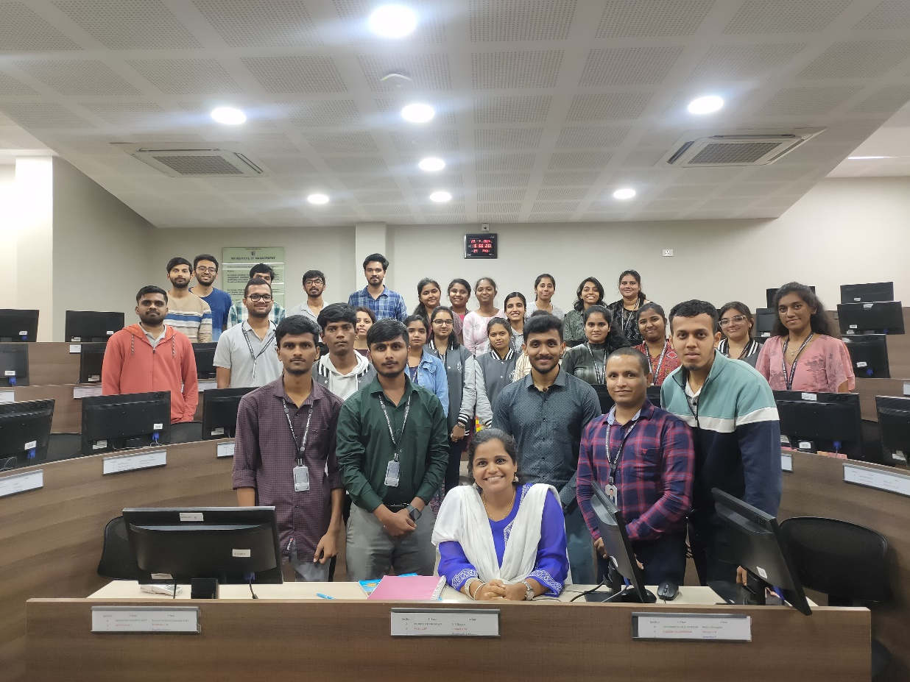

TEST RESULTS:

Total score | Name of Student | Register Number
12.00 / 25 | Arpita Deshpande | P18FW23M015018
23.00 / 25 | C Bhargavi | P18FW23M015027
16.00 / 25 | preetham | P18FW23M015093
22.00 / 25 | Nandisha V | P18FW23M015073
22.00 / 25 | Supritha T | P18FW23M015172
22.00 / 25 | B.Gayathri | P18FW23M015023
20.00 / 25 | RAKSHA R | P18FW23M015102
22.00 / 25 | sushmitha | P18FW23MO15145
22.00 / 25 | Sahana Madhukar Kokkalaki | P18FW23M015114
20.00 / 25 | Venkatesh Gouriprur | P18FW23M015157
22.00 / 25 | Faizan Khan | P18FW23M015034
25.00 / 25 | Karthik G R | P18FW23M015046
20.00 / 25 | Megha Santosh Angadi | P18FW23M015066
22.00 / 25 | Spoorthi Ganapati Naik | P18FW23M015136
25.00 / 25 | Shilpa. R | P18FW23MO15127
24.00 / 25 | Hrithik N | P18FW23M015043
20.00 / 25 | Sadwi P Shetty | P18FW23M015113
22.00 / 25 | Varsha Sharada Y | P18FW23M015154
21.00 / 25 | SADIYA KHUDEJA | P18FW23M015112
23.00 / 25 | Chaitanya S | P18FW23M015028
21.00 / 25 | Sowjanya | P18FW23M015130
21.00 / 25 | VITHESH S SUVARNA | P18FW23M015161
22.00 / 25 | ADHVI SU | P18FW23M015005
21.00 / 25 | Sannidhi S Shetty | P18FW23M015119
20.00 / 25 | Purvi | P18FW23M015099
22.00 / 25 | Aishwarya D Warkar | P18FW23M015007
21.00 / 25 | Chirag S M | P18FW23M015030
21.00 / 25 | Arun Biradar | P18FW23M015019
25.00 / 25 | Likhith El | P18FW23M015058
20.00 / 25 | P.Uttara | P18FW23M015082
22.00 / 25 | Priyadarshan D Shenvi | P18FW23M015094
22.00 / 25 | Dushyanth N | 7892987573
21.00 / 25 | Pradnya Naik | PFW23M015086
25.00 / 25 | G.P Tejishree | P18FW23M015036
23.00 / 25 | Neha Prasad | P18FW23M015077
22.00 / 25 | Kavya M P | P18FW23M015052
20.00 / 25 | Priyanka R | P18FW23M015095
21.00 / 25 | Steffi Fatima Dsouza | P18FW23M015137
22.00 / 25 | Karthik H N | P18FW23M015047
23.00 / 25 | A C HARSHA | P18FW23M015001
20.00 / 25 | Prathvi Annappa Hegde | P18FW23M015092
22.00 / 25 | Medha. B | P18FW23M015065
23.00 / 25 | ARUN KUMAR M | P18FW23M015020
23.00 / 25 | Sarvashri Gaonkar | P18FW23M015121
25.00 / 25 | Shetty Sajjan Sadashiva | P18FW23M015126
25.00 / 25 | Abhishek SK | P18FW23MO15004
21.00 / 25 | Karthik NP | P18FW23M01549
25.00 / 25 | Mark | P18FW23M015071
24.00 / 25 | Kavya D | P18FW23M015051
25.00 / 25 | Neha Chougale | P18FW23M015076
23.00 / 25 | BISHAN | P18FW23M015026
25.00 / 25 | Vishal Dhage | P18FW23M015160
22.00 / 25 | Kishor | P18FW23MO051
25.00 / 25 | SANTOSH L | P18FW23MO15120
25.00 / 25 | Narayana R Pujari | P18FW23M015074
25.00 / 25 | P.Ashritha | 20YUC26078
22.00 / 25 | Aishwarya | P18FW23MO15008
25.00 / 25 | Sushanth shetty | P18FW23MBA015144
24.00 / 25 | Maryam fathima | P18FW23M015063
25.00 / 25 | Shivaraj Mallappa Jagapur | P18FW23M015129
20.00 / 25 | MAMATHA S | P18FW23M015059
24.00 / 25 | Pavan | P18FW23M015083
25.00 / 25 | Vindhya Rajendra Hegde | P18FW23M015159
21.00 / 25 | Sakshi B Malipatil | P18FW23M015116
21.00 / 25 | Karthik G | P18FW23M015048
18.00 / 25 | Harshith G | P18FW23M015039
24.00 / 25 | Shreya.S.H | P18FW23M015132
24.00 / 25 | BGS MAYUR SHANKAR | P18FW23MBA015024
25.00 / 25 | SWATHI GUDOOR | P18FW23M015147
21.00 / 25 | Hrishikesh dabade | P18FW23M0150042
24.00 / 25 | Saumya Sanchita | P18FW23M015122
25.00 / 25 | Mohith M | P18FW23M015068
24.00 / 25 | sayed awaise | P18FW23M015123
22.00 / 25 | Rajashree S S | P18FW23M015100



Co-ordinator Director




CA 17, 36th Cross Rd, 26th Main, 4th T Block East
Bengaluru - 560041, Karnataka, India
080 42540300
080 26547048
www.rvim.edu.in
Scan Here

