RASHTREEYA SIKSHANA SAMITHI TRUST
R V INSTITUTE OF MANAGEMENT
CA 17, 26 Main, 36th Cross, 4th T Block, Jayanagar Bengaluru, Karnataka 560 041

REPORT ON
Minutes of the Half-Yearly Alumni Association Office Bearers Meeting

- Date: July 9, 2025  - Time: 4:00 PM - 5:00 PM | - Venue: Venue: Board Room, R.V. Institute of Management (RVIM), Bangalore
Attendees:
The following Teaching and Administrative Staff Members joined physically:
- Dr. Purushottam Bung – Professor and Director
- Dr. Srikanth P - Convenor
- Prof. Sowmya DS
- Dr. Sunitha Parameshwaran – Head, Placement and Training
- Prof. Manjunath SK – PRO
- Ms. Lakshmi Somashekar
The following new Student Office Bearers attended physically:
- Ms. Akshita Prasad
- Ms. Amulya Mahindrakar
- Mr. Sumanth Holla
- Ms. Vidyashree
The following members attended through the online mode:
- Mr. Vikas VB
- Mr. Supreeth T
- Mr. Hemanth C
- Ms. Akshata Siked – Student Member
Proceedings
- Commencement of Meeting
- The meeting commenced at 4:00 PM with a Silent Prayer.

- Opening Remarks and Formal Welcome
- The Director provided a brief overview of the meeting's agenda.
- Dr. Srikanth P extended a formal welcome to all the members.

- Welcome and Introductions of new members
- New members, Dr. Sunitha P from the Placement Cell and Dr. Srikanth P from the Department of Finance, were formally welcomed to the meeting.
- The new student office bearers Ms. Akshita Prasad, Ms. Amulya Mahindrakar, Mr. Sumanth Holla, Ms. Vidyashree and Ms. Akshata Siked were also welcomed.

- Acknowledgment of Outgoing Members
- Ms. Payal Jindal the previous convenor was thanked for her contributions as member.
- The student members of the passed-out batch Ms. Hema Srinivas, Mr. Vishnu, Ms. Shjeebal, Ms. Namratha Gowda N were also thanked for their role and contributions.

- Updates on the Academic and Research Initiatives at the Institutes
The alumni were updated on the following initiatives in academics and research:
- BIP Projects to Case Studies/Publications: Efforts to convert students' BIP (Business Immersion Program) projects into case studies and useful publications were highlighted. It was noted that 10 papers have been published through this initiative to date.
- Research Bulletin Release: The release of the Research Bulletin, which features faculty publications, was discussed. The plan is to continue with two issues annually (one in every six months).
- Ongoing Research, Consultancy & Extension Projects: A discussion took place regarding the progress and status of ongoing research, consultancy, and extension projects within the institute.

- Student Development and Achievements
- Coursera Licenses: The increase in Coursera licenses from 180 to 360 was noted, providing unlimited access without restrictions on the number of certifications.
- Outbound Training: The successful outbound training program conducted for first-semester students to enhance team-building activities was mentioned.
- 2nd BIDA Conference: The successful conduct of the 2nd Business Intelligence and Data Analytics (BIDA) conference on April 12th & 13th, 2025, was reported.
- Upcoming International Conference: A conference scheduled for August with Washington University was discussed, highlighting its potential benefits for the Institute.
- Start-up Mahakumbh: The "OZY team" of 10 students participated in Start-up Mahakumbh and won a cash prize of ₹2.5 lakhs as initial funding for their startup.
- Anveshan 2025: This event involved students preparing presentations on MRSL (presumably a specific topic or theme), with participation from students from 10 other colleges who also presented their papers.
- International Immersion Program: A discussion was held on the ongoing international immersion program.

- Institutional Achievements
- Infrastructure Development: The Centre of Placement Cell has been refurbished.
- Incubation Cell: An Incubation Cell will be opening shortly, with opportunities for alumni participation.
- Programs Organized & MoUs: Information was shared regarding programs organized and various Memoranda of Understanding (MoUs) signed.
- Placement Updates
  - Updates were provided on the placement status of the 2023-2025 batch.
  - Details were shared regarding upcoming companies for the placement of the 2024-2026 batch. Various institutional achievements were discussed to keep the alumni informed about the progress and growth of RVIM.

- Funding and Social Activities:
- Received INR 12 lakhs from ICSS.
- Generated INR 4 lakhs from consultancies, which is utilized for teaching underprivileged girl children at KGBB schools in partnership with Aditya Birla.
- Ongoing initiatives included Gyanarajana and the Senior Citizen Computer Literacy Program.

- Alumni Engagement and Updates
- Alumni Status Update: Discussions were held regarding the current status of alumni students, including their interest areas, to facilitate better engagement.
- Startup Incubation Opportunity: Alumni students will be provided an opportunity to visit the campus and work on their startup ideas in the upcoming incubation cell and activity room.

- Alumni Meet Planning:
- The Alumni Meet date was tentatively fixed for August 30, 2025.
- A brainstorming session was conducted to explore ideas for making the event more attractive and engaging for alumni.

- Conclusion
- The meeting concluded with a productive discussion on various initiatives and plans for the alumni association and the institute. The Director and the convenor thanked all the members who have attended for taking time of their busy schedule.

- Action Items and Responsibilities
- Alumni Achiever Award: Prof. Uma & Dr. Srikanth are responsible for identifying different categories and calling for nominations.
- Involving Alumni in various college activities: Dr. Sunitha and Ms. Lakshmi are responsible for this initiative.
- Planning for different activities for Alumni Meet: Prof. Sowmya and Prof. Pooja are responsible for activity planning.
- Budget and Creative: Prof. Manjunath SK will prepare and oversee the budget and creative aspects of the initiatives.
- Weekly Progress: The members will meet every Wednesday 4.00 PM – 5.00 PM to update on the progress.

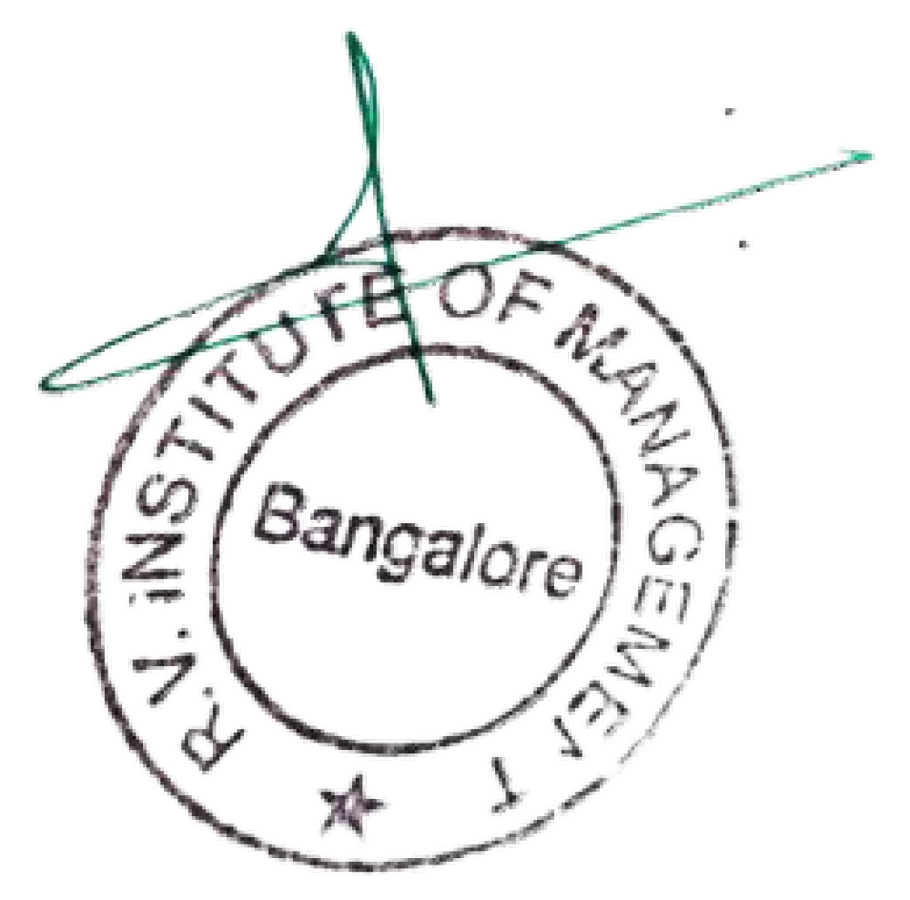
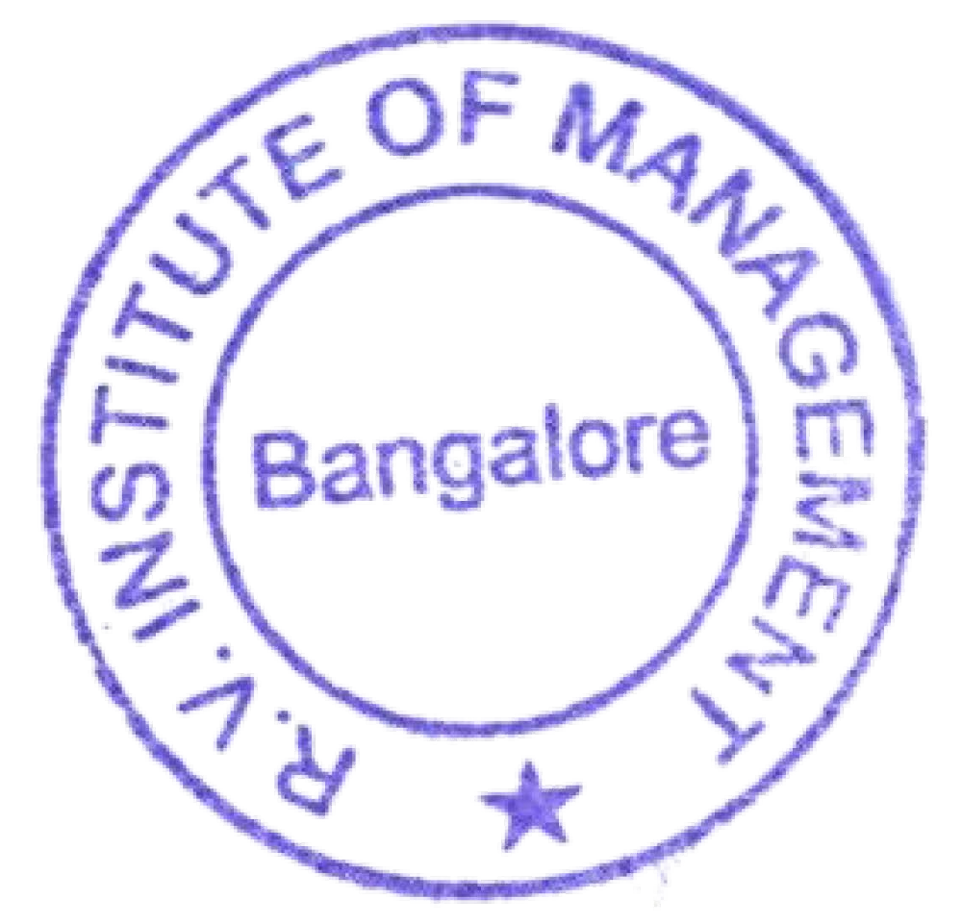
Sd/-

Dr.Purushottam Bung Professor & Director RVIM

