Report on Independence Day Celebration
Date: 15 August 2024 | Venue: SSMRV Quadrangle
Time: 7:30 AM onwards | Event :Independence Day Celebration
No. of Participants: 120 | Event Coordinators: Dr. Anupama Malagi
The Independence Day Celebration at RV Institute of Management was held on 15 August 2024 at the SSMRV Quadrangle. The event was organized under the banner of Azadi Ka Amrit Mahotsav, commemorating India’s 78th Independence Day. Faculty members, staff, and students gathered to honor the nation’s freedom and reflect on its journey of progress. The program began with the flag hoisting ceremony, followed by patriotic songs, speeches, and cultural performances.
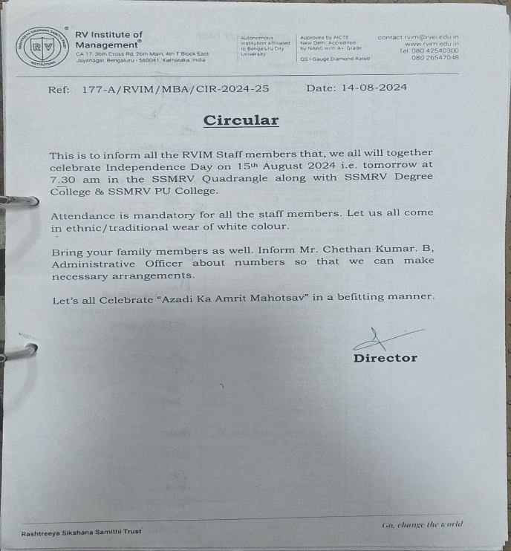
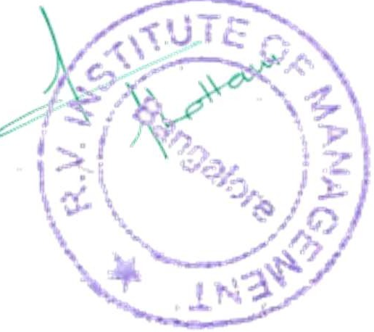
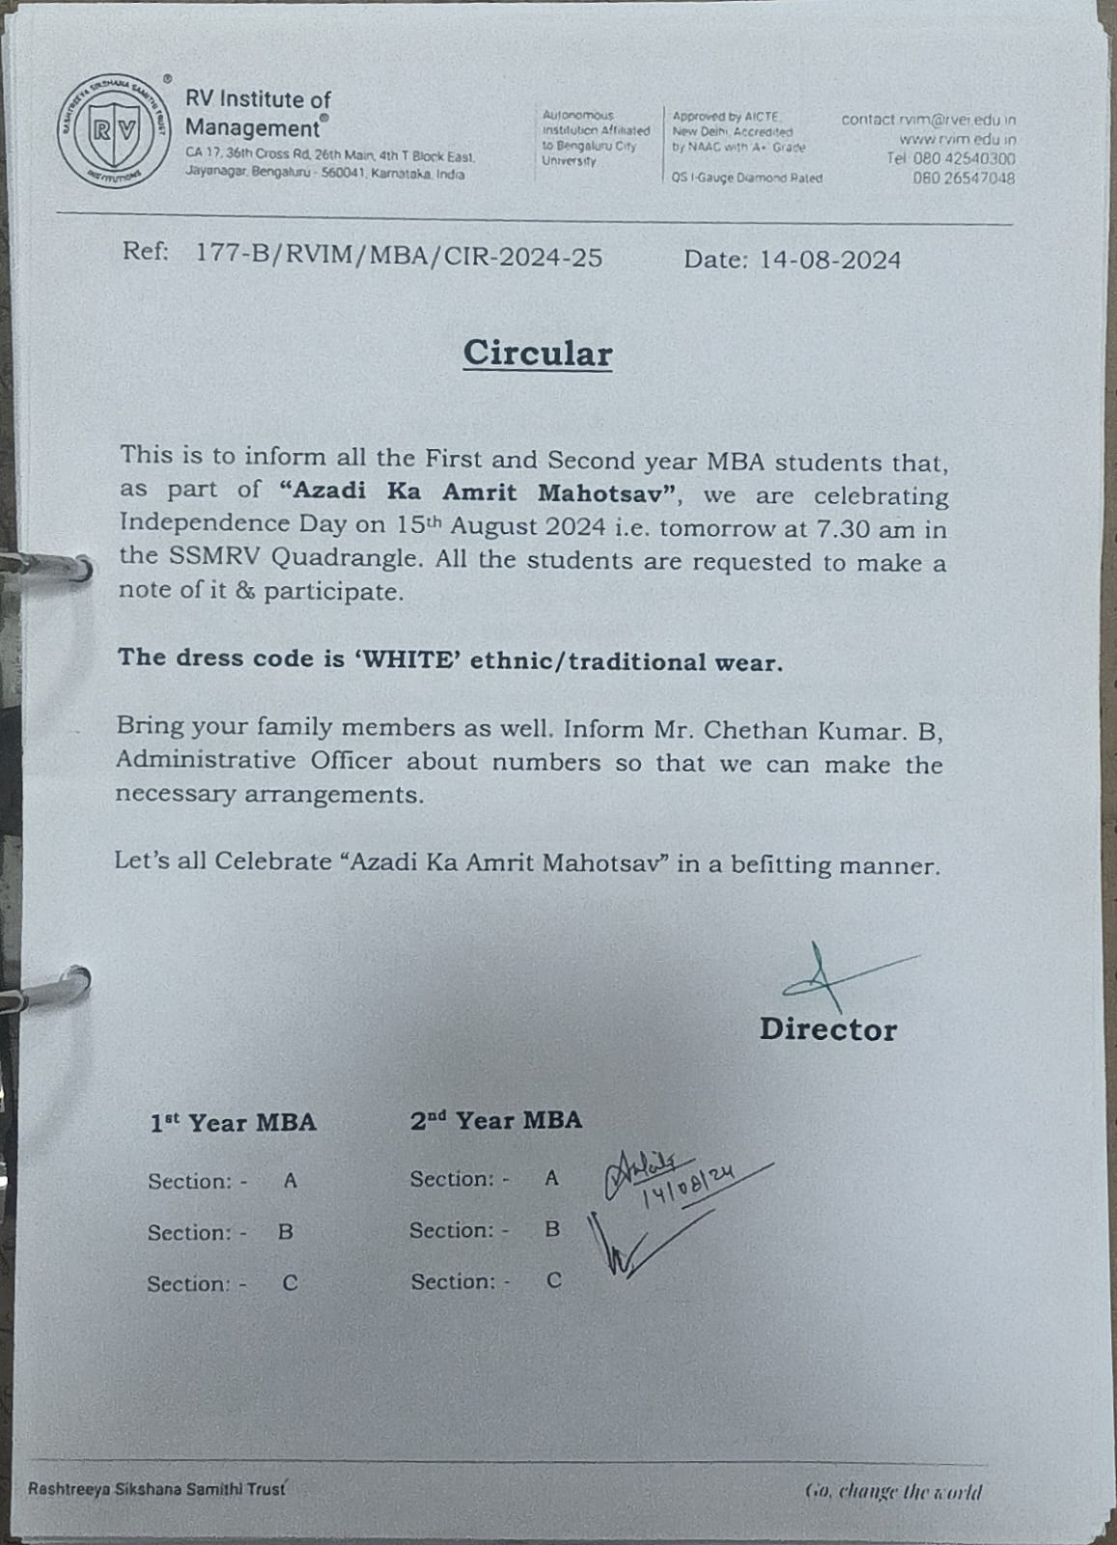
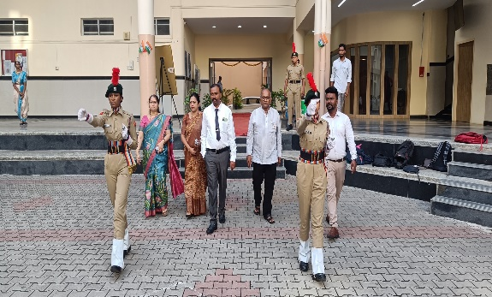 | 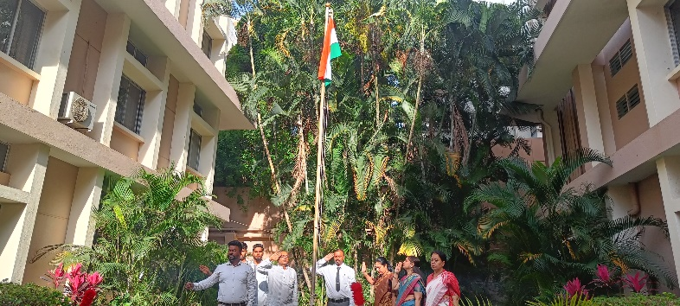
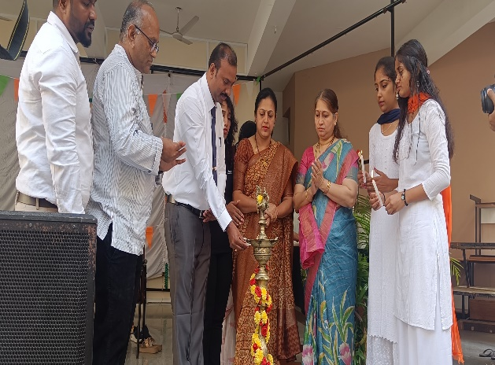 | 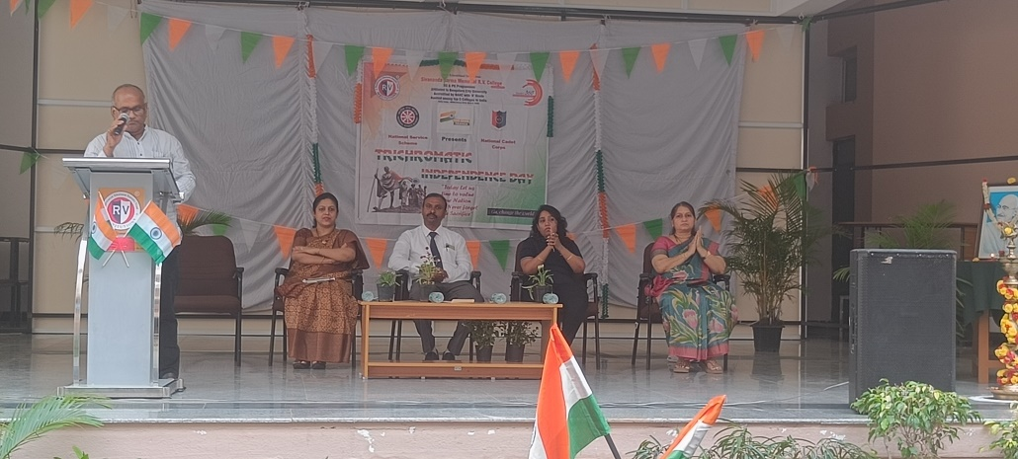
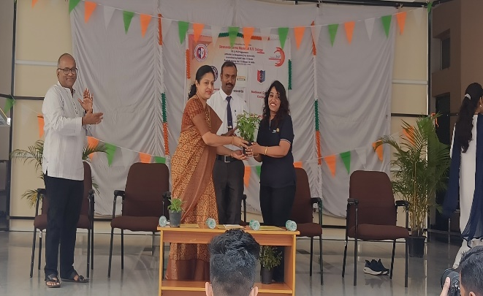 | 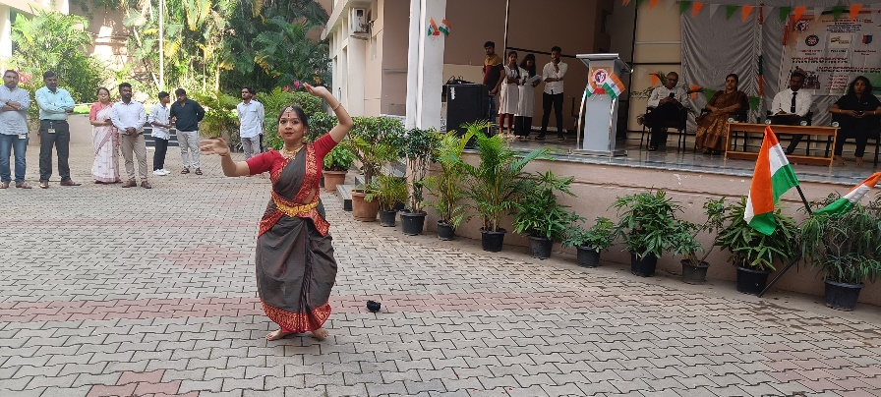

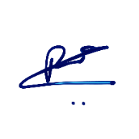

Event Co-ordinator Director





CA 17, 36th Cross Rd, 26th Main, 4th T Block East
Bengaluru - 560041, Karnataka, India
080 42540300
080 26547048
www.rvim.edu.in
Scan Here

