Report on Kannada Rajyotsava Celebration
Date: 9 November 2024 | Venue: DAPM RV DENTAL COLLEGE AUDITORIUM
Time: 2:00 PM onwards | Event : Kannada Rajyotsava Celebration
No. of Participants: 150 | Event Coordinators: Prof. Pooja T.
Kannada Rajyotsava was celebrated with great pride and cultural fervour at RV Institute of Management (RVIM) on 1st November 2024, marking the formation of the state of Karnataka and celebrating the rich heritage of the Kannada language and culture.
The celebration commenced at 10:00 AM with a formal gathering of faculty members, staff, and students. The campus was adorned with decorations reflecting the spirit of Karnataka’s culture, featuring traditional motifs and the state colours of red and yellow. The event aimed to instil a sense of regional pride and promote awareness of Karnataka’s linguistic and cultural legacy among students.
The programme included a series of cultural performances by students, such as Kannada songs, folk dances, skits, and poetry recitations, showcasing the diversity and vibrancy of Karnataka’s traditions. Students actively participated with enthusiasm, expressing their respect for the Kannada language and its literary and artistic contributions.
Faculty members addressed the gathering, emphasizing the importance of preserving and promoting Kannada language and culture in contemporary society. The celebration also highlighted the values of unity in diversity and cultural harmony.
The Kannada Rajyotsava celebration at RVIM provided a meaningful platform for students to connect with local culture and traditions. The event concluded on a patriotic and celebratory note, leaving participants with a renewed sense of pride in Karnataka’s heritage.
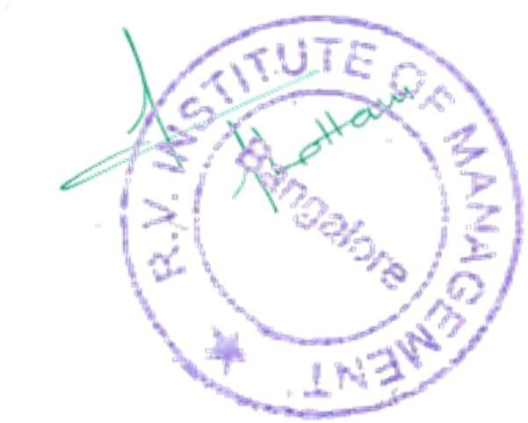
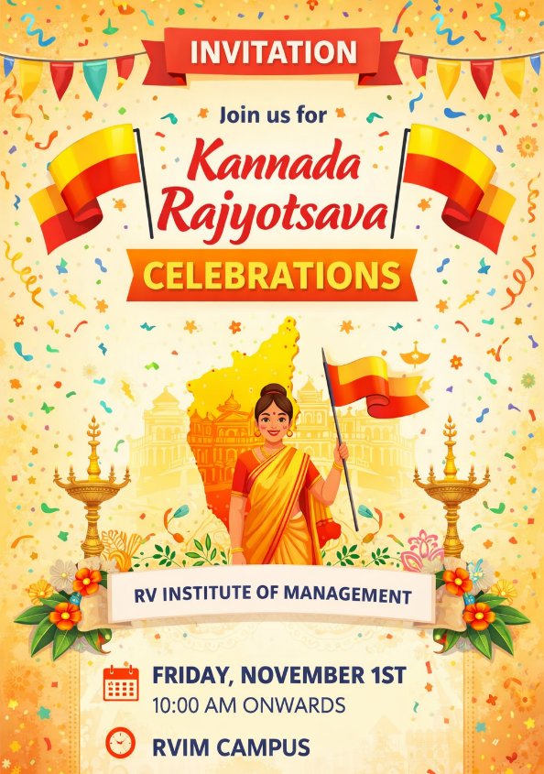

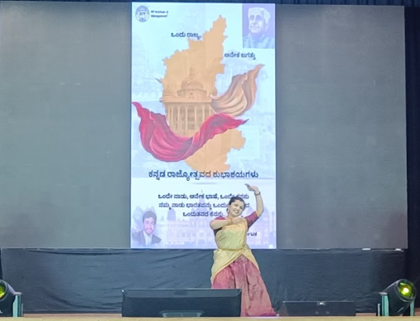
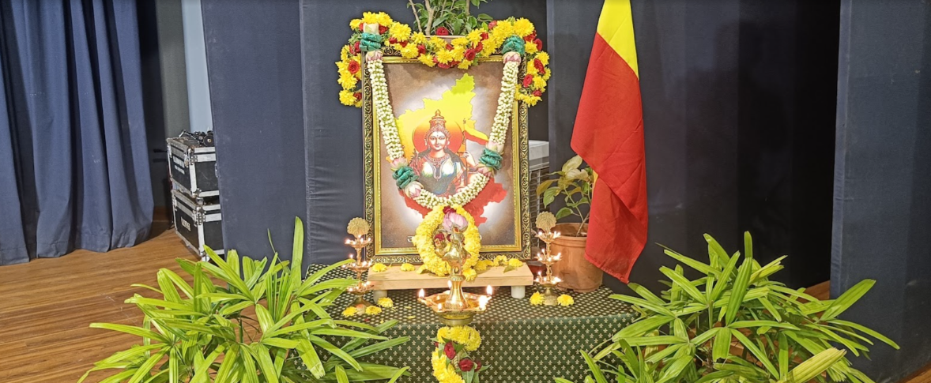

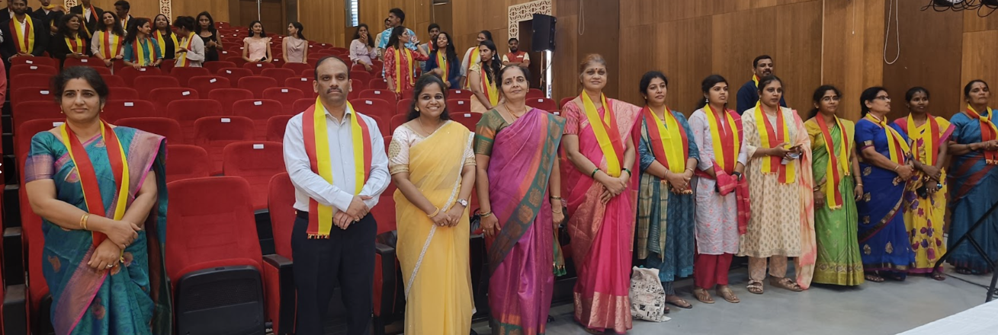
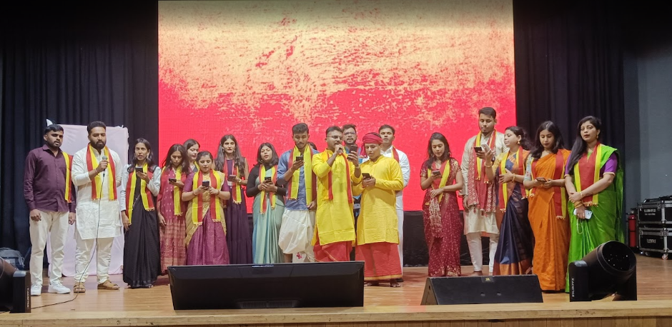
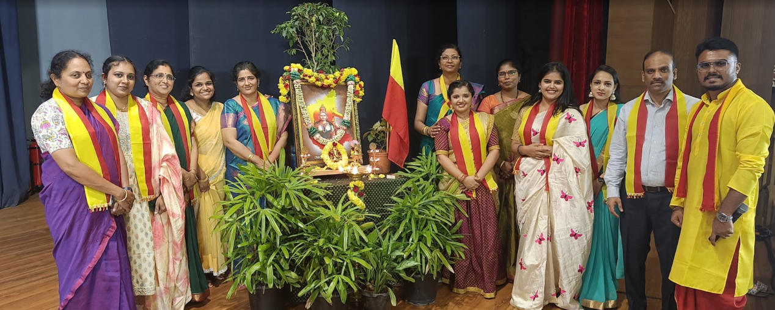

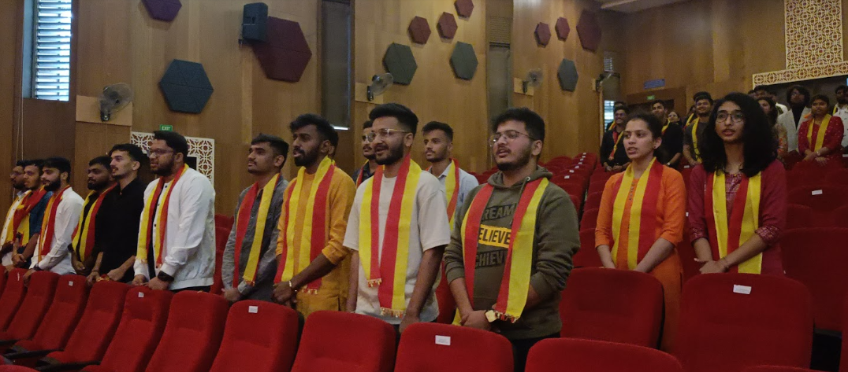



Event Co-ordinator Director





CA 17, 36th Cross Rd, 26th Main, 4th T Block East
Bengaluru - 560041, Karnataka, India
080 42540300
080 26547048
www.rvim.edu.in
Scan Here

