Report on Matrabhasha Divas 2025
Date: 13 - 03 - 25 | Venue: RVIM Quadrangle
Time: 11 AM | Event: Matrabhasha Divas 2025
No. of Participants: 300 | Event Coordinators: Dr. Uma Sharma, Prof. Pooja T.
Matrabhasha Divas 2025 was celebrated with great enthusiasm and cultural fervour at RV Institute of Management, highlighting the linguistic and cultural diversity of India. The event served as a meaningful platform to honor and promote the importance of mother tongues while fostering unity in diversity among students and faculty members. Celebrated over two days, the program created an enriching experience that beautifully blended tradition, creativity, and management values.

In a management institution, language plays a vital role in communication, leadership, and inclusivity. Matrabhasha Divas emphasized the significance of respecting one’s roots while developing global managerial competencies. The celebration reinforced the idea that understanding and valuing linguistic diversity enhances interpersonal skills, cultural sensitivity, and ethical leadership - essential qualities for future managers and business leaders.

A variety of cultural activities such as dance, singing, ramp walk, and presentations were conducted, providing students with an opportunity to express their talents and cultural identity. The performances showcased regional art forms, folk traditions, and linguistic pride, leaving the audience thoroughly entertained and inspired. One of the highlights of the celebration was the inclusion of both section- wise and individual competitions, encouraging teamwork as well as personal excellence

The success of Matrabhasha Divas 2025 can be credited to the meticulous planning and seamless execution by the students, with constant support and guidance from the faculty and staff. The coordination, time management, and smooth flow of events demonstrated excellent organizational skills, reflecting the strong collaborative culture of the institution.

The event beautifully aligned with the values of a management institution by promoting inclusivity, leadership, teamwork, and effective communication. It stood as a testament to the collective efforts of students and staff, making it a grand success and a truly memorable celebration at RV Institute of Management.

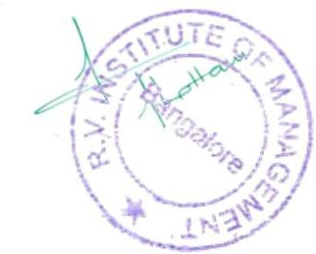
PHOTO GALLERY:

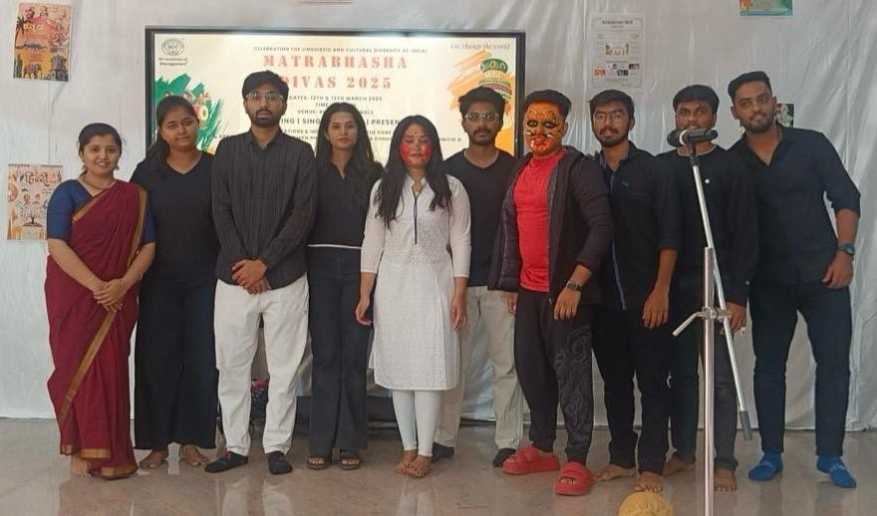 | 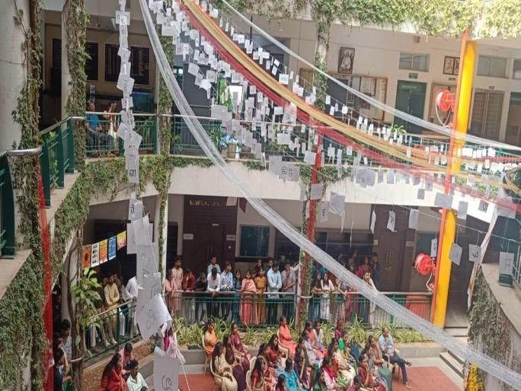
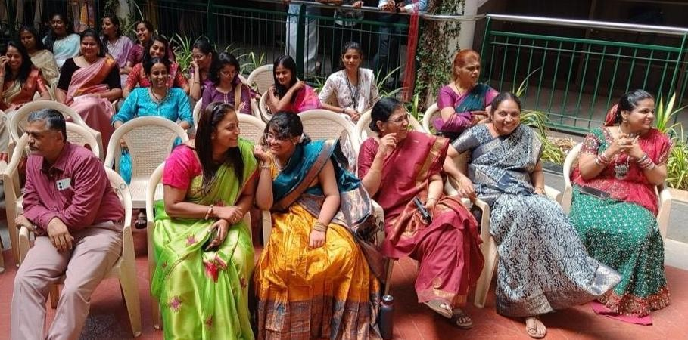 | 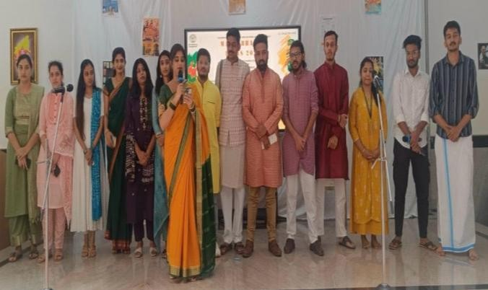


Event Co-ordinator Director

