REPORT ON RVIM KREEDA CARNIVAL

RVIM Rotaract Club organized KREEDA CARNIVAL a Indian traditional games carnival for all institutions of RVIM on the 24th of January’25. The carnival hosted traditional games Staff and Students participated actively in the CARNIVAL.
Date: 24th January’25 | Venue: SSMRV Quadrangle and Ground
Time: 9 am to 5.30 pm | Event : Indian Traditional Games Carnival
No. of Participants: 132 | Co-ordinators:  Uma Sharma and Dr.Vinay
Brief Details of the Camp:  RVIM Rotaract Club organized KREEDA CARNIVAL a Indian traditional games carnival-board games, outdoor games were conducted. | Total Donation at the Camp: Students and Staff of PU College, Degree and PG college of RV Institutions Participated.
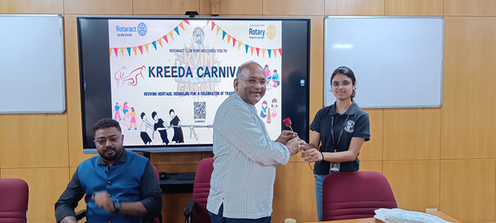

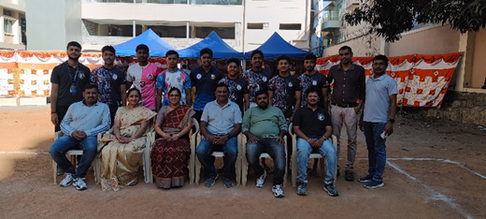

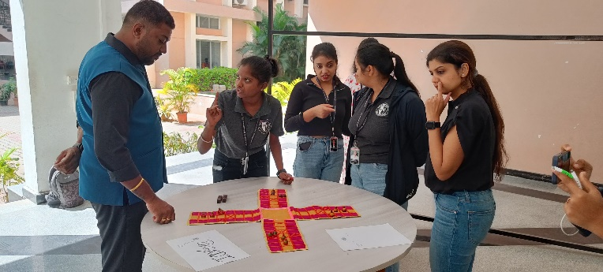

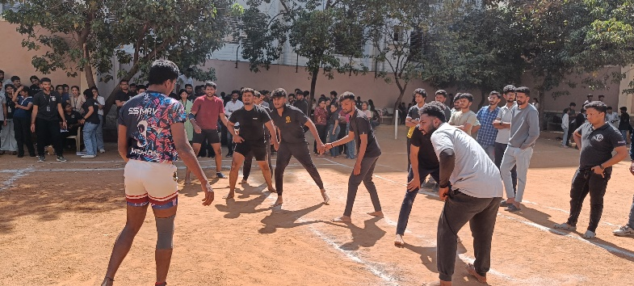

RVIM Kreeda Carnival 2025

RVIM Rotaract club organized a one day Indian Traditional Games Carnival the –RVIM Kreeda
Carnival on the 24 th of January’25, The carnival was a platform for students and staff from PU
College to PG college of the RV group to enliven their gaming interest by playing the age old
board games as Adagullimane, Chokabhara, Snake n Ladder to the outdoor team games like
Lagori, Kabbadi and Gillidhanu and Spinning Tops. Students and Staff participated and enjoyed
in the spirit of Indianess. Winners were recognized with certificate of recognition and medal.



Dr. Purushottam Bung,
Professor and Director,
Director
RV Institute of Management-Bangalore- 560041

