Report on Independence Day Celebration
Date: 26 January 2025 | Venue: SSMRV Quadrangle
Time: 7:30 AM onwards | Event :Republic Day Celebration
No. of Participants: 110 | Event Coordinators: Dr. Anupama Malagi
The Republic Day Celebration at RV Institute of Management was held on 26 January 2025 at the SSMRV Quadrangle. The event brought together faculty, staff, and students to honor India’s 76th Republic Day. The program began with the flag hoisting ceremony, followed by the national anthem and cultural performances. Participants reflected on the values enshrined in the Constitution and celebrated the spirit of unity and democracy.
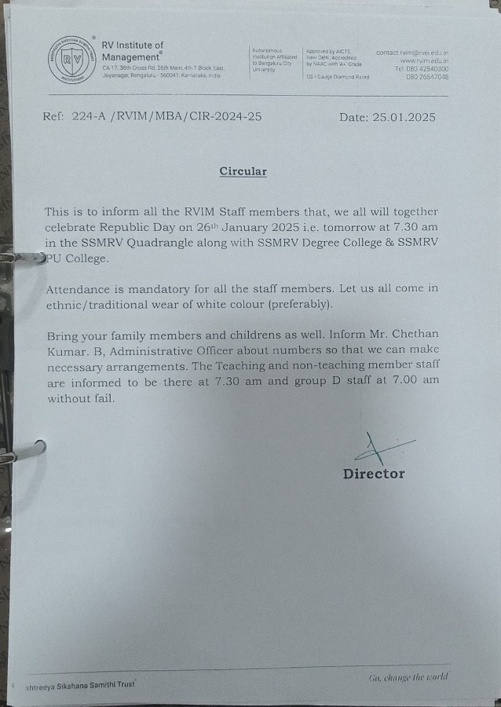
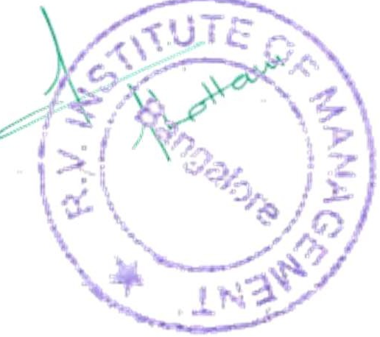
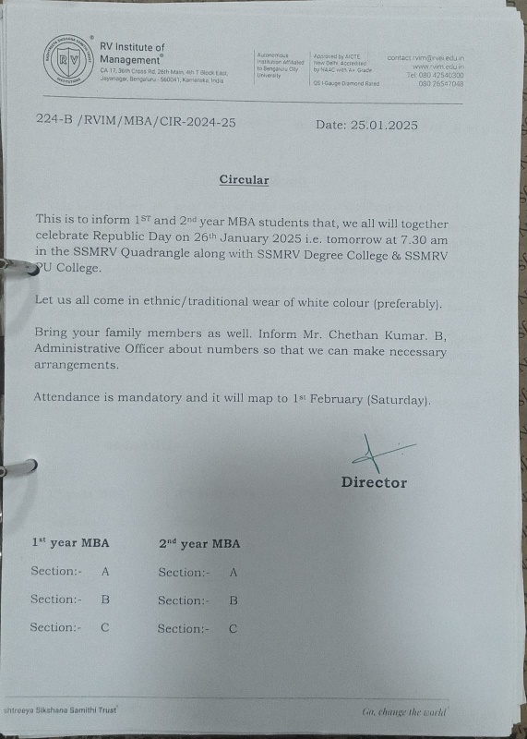
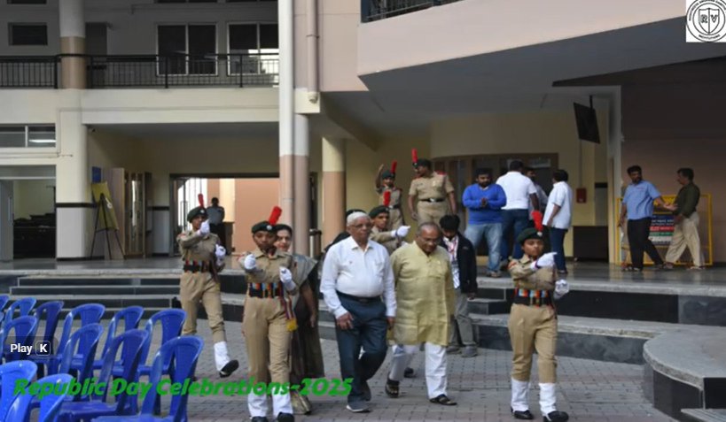 | 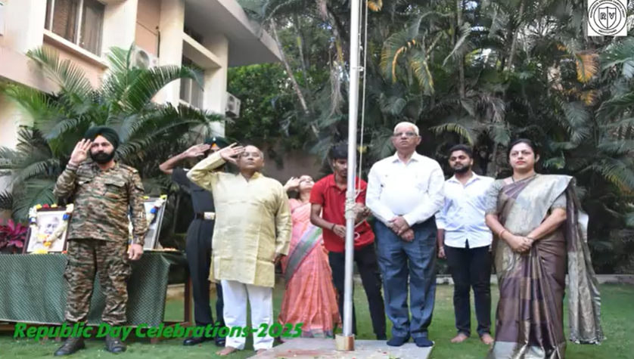
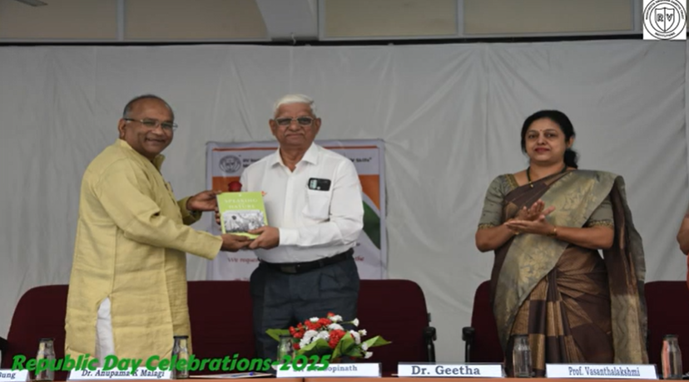 | 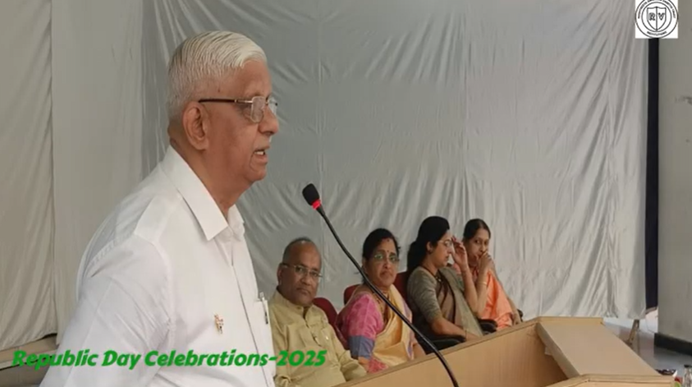
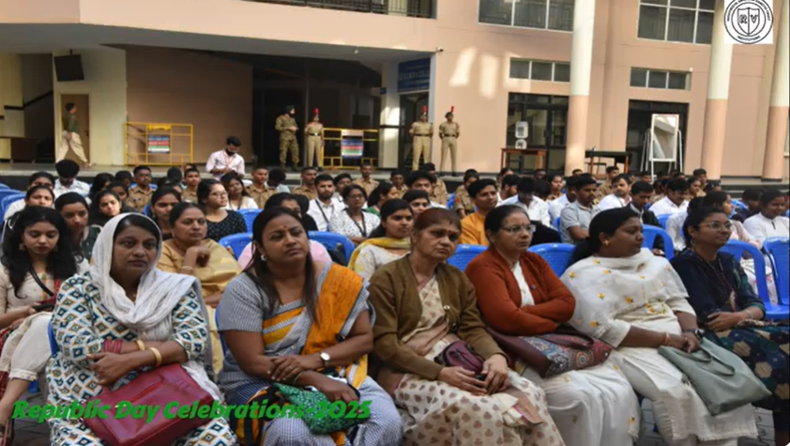 | 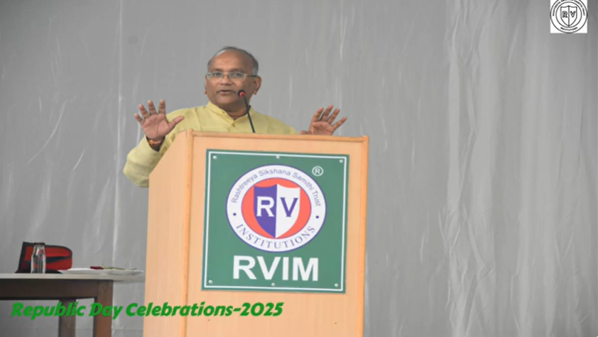



Event Co-ordinator Director





CA 17, 36th Cross Rd, 26th Main, 4th T Block East
Bengaluru - 560041, Karnataka, India
080 42540300
080 26547048
www.rvim.edu.in
Scan Here

