Report on Teachers’ Day Celebration
Date: 5 September 2024 | Venue: Seminar Hall, 3rd Floor, RVIM
Time: 3:30 PM onwards | Event : Teachers’ Day Celebration
No. of Participants: 150 | Event Coordinators: Prof. Pooja T.
Teachers’ Day was celebrated with great enthusiasm and gratitude at RV Institute of Management on 5th September 2024, commemorating the birth anniversary of Dr. Sarvepalli Radhakrishnan, a distinguished scholar, philosopher, and former President of India.
The event was organized by the students of the 2023–25 MBA batch as a token of appreciation for the invaluable contributions of the faculty members. The celebration aimed to acknowledge the dedication, commitment, and continuous guidance provided by teachers in shaping students’ academic and professional journeys.
The program commenced at 3:30 PM in the Seminar Hall, 3rd Floor, with a warm welcome extended to all faculty members. The venue was tastefully decorated, reflecting the spirit of celebration. Faculty members were requested to attend the event in traditional attire, adding cultural elegance to the occasion.
The celebration featured a series of student-led activities, including heartfelt speeches, cultural performances, and interactive segments, all expressing gratitude and respect towards the teaching fraternity. Students shared their experiences and acknowledged the pivotal role played by teachers in nurturing knowledge, values, and leadership skills.
The event fostered a warm and cordial atmosphere, strengthening the bond between students and faculty. The celebration concluded on a joyful note, with students expressing sincere thanks to all teachers for their unwavering support and inspiration.
The Teachers’ Day celebration at RVIM was a meaningful and memorable event that reinforced the institute’s culture of respect, gratitude, and academic excellence.

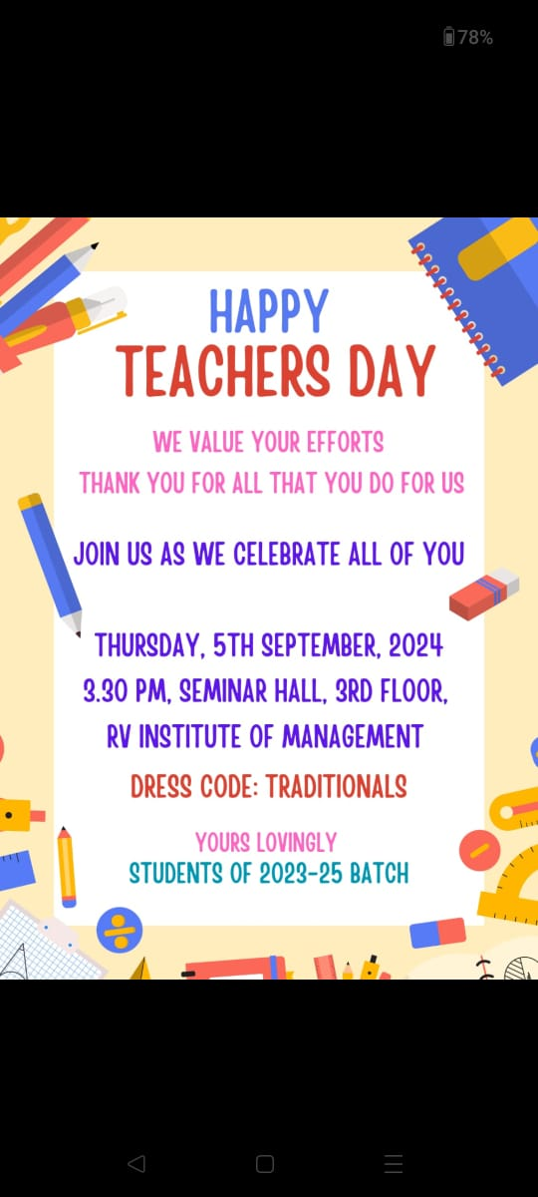
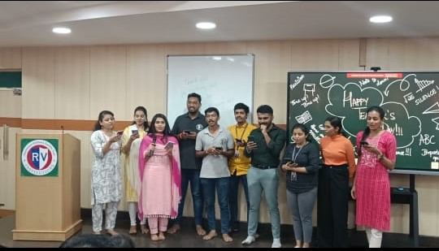
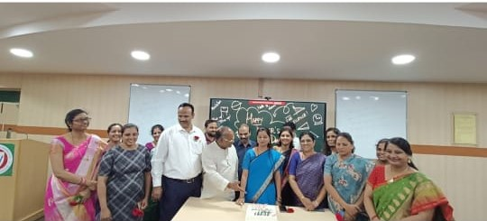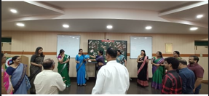

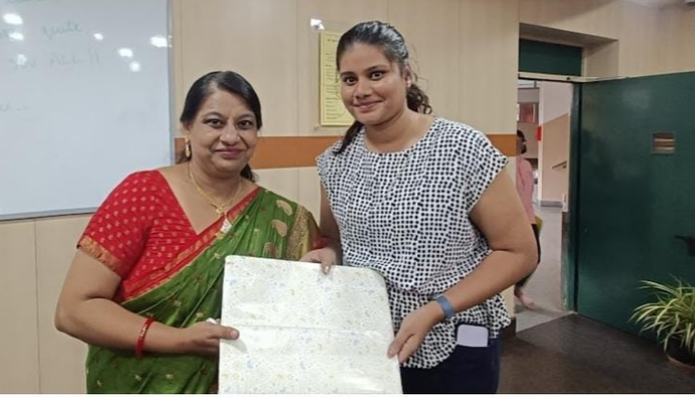
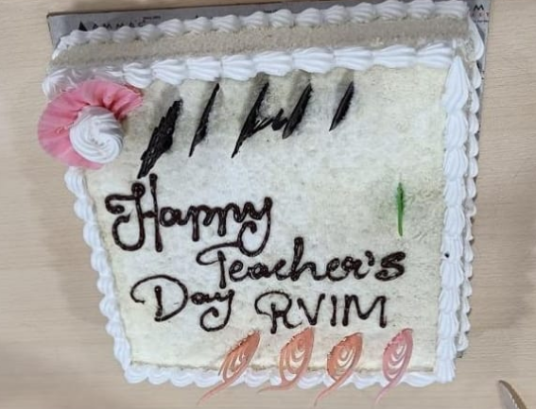
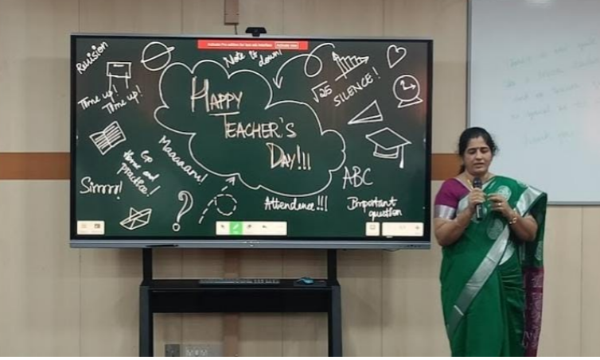

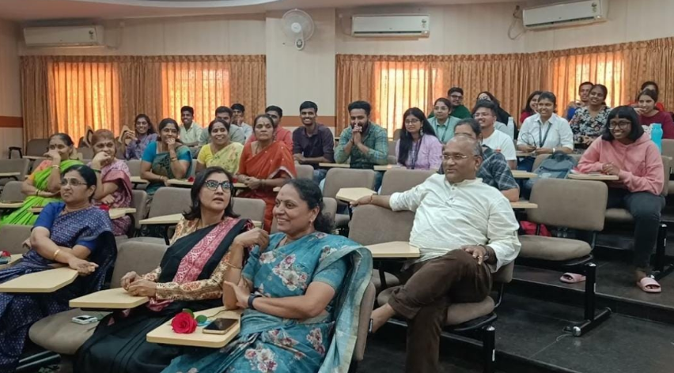

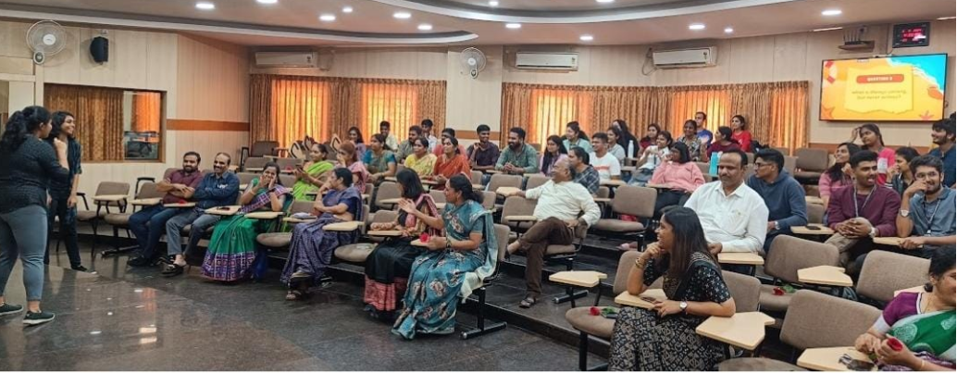




Event Co-ordinator Director





CA 17, 36th Cross Rd, 26th Main, 4th T Block East
Bengaluru - 560041, Karnataka, India
080 42540300
080 26547048
www.rvim.edu.in
Scan Here

