 | RASHTREEYA SIKSHANA SAMITHI TRUST®    RV INSTITUTE OF MANAGEMENT  (Autonomous Institution Affiliated to BCU)  REPORT ON  SCRIBE ASSISTANCE IN EXAMINATIONS | 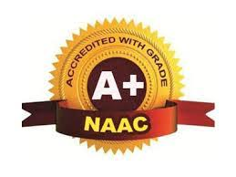
For the blind students of Premanjali NGO, JP Nagar
From 1st and 2nd year MBA students
June-July 2025
Objective: To promote inclusivity and equal opportunity for students with disabilities

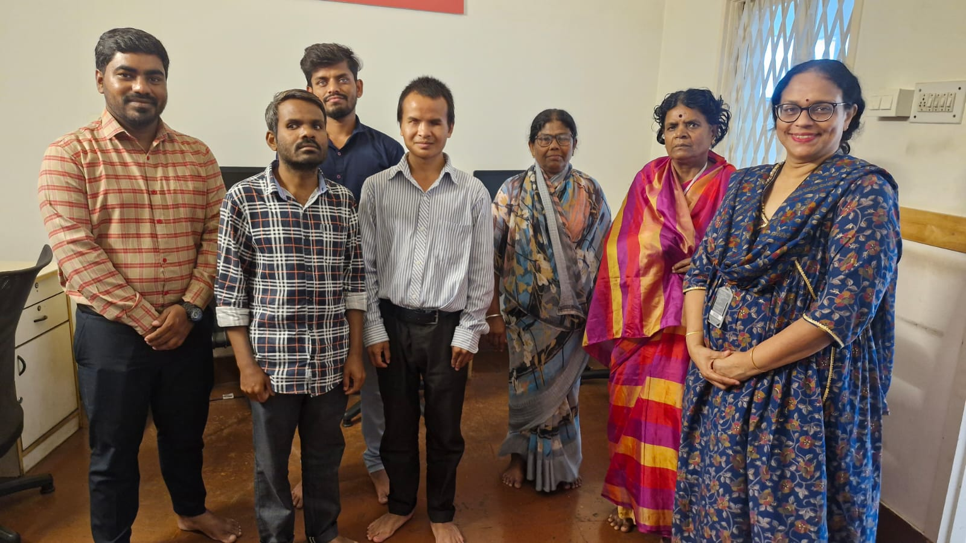

Student name: Mr. Vinay R, 4th Semester Section C
Date: Friday, 13th June 2025
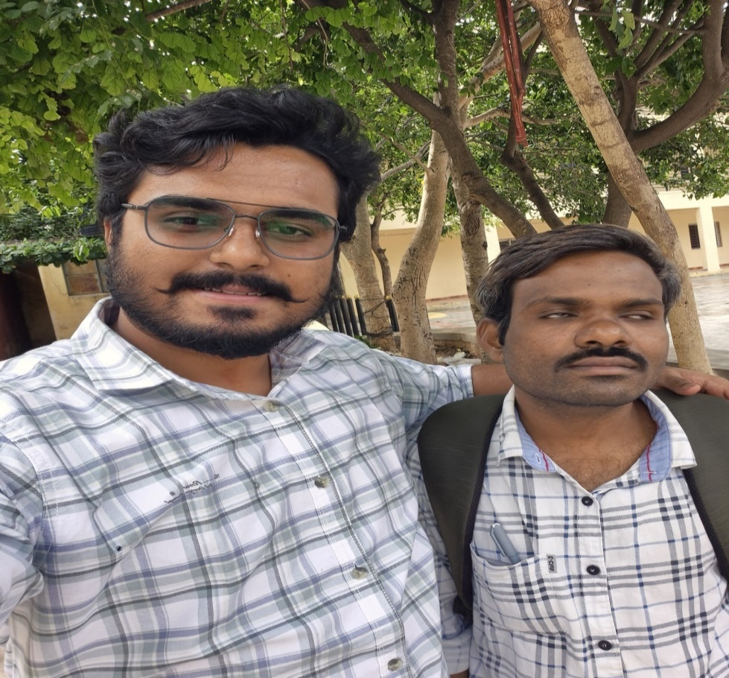

Student name: : Ms. Navyashree M from 2nd Semester Section C
Date: Friday, 17th June 2025
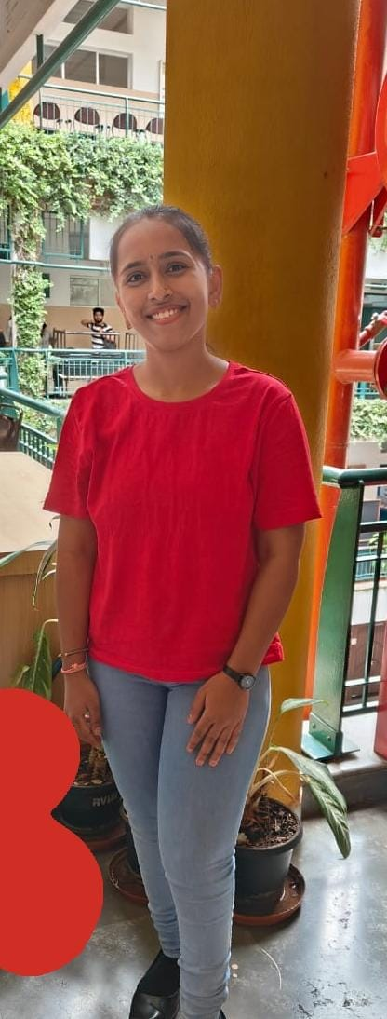

Student name: Mr. Abhiram Bhat from 2nd Semester Section A
Date: Thursday, 19th June 2025

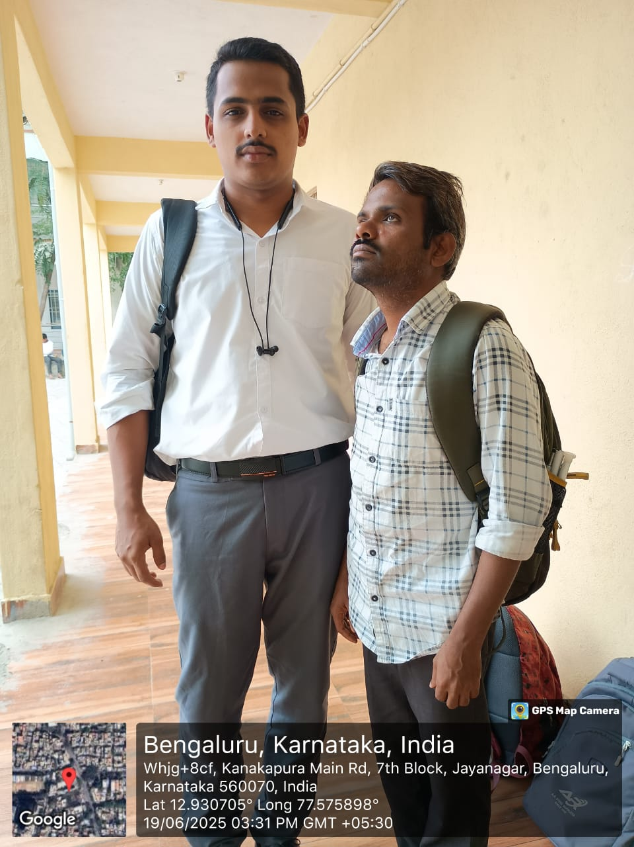

Students name : Ms. Sowjanya Shetty and Mr. Vinay R from 4th Semester C Section
Date: Thursday, 19th June 2025
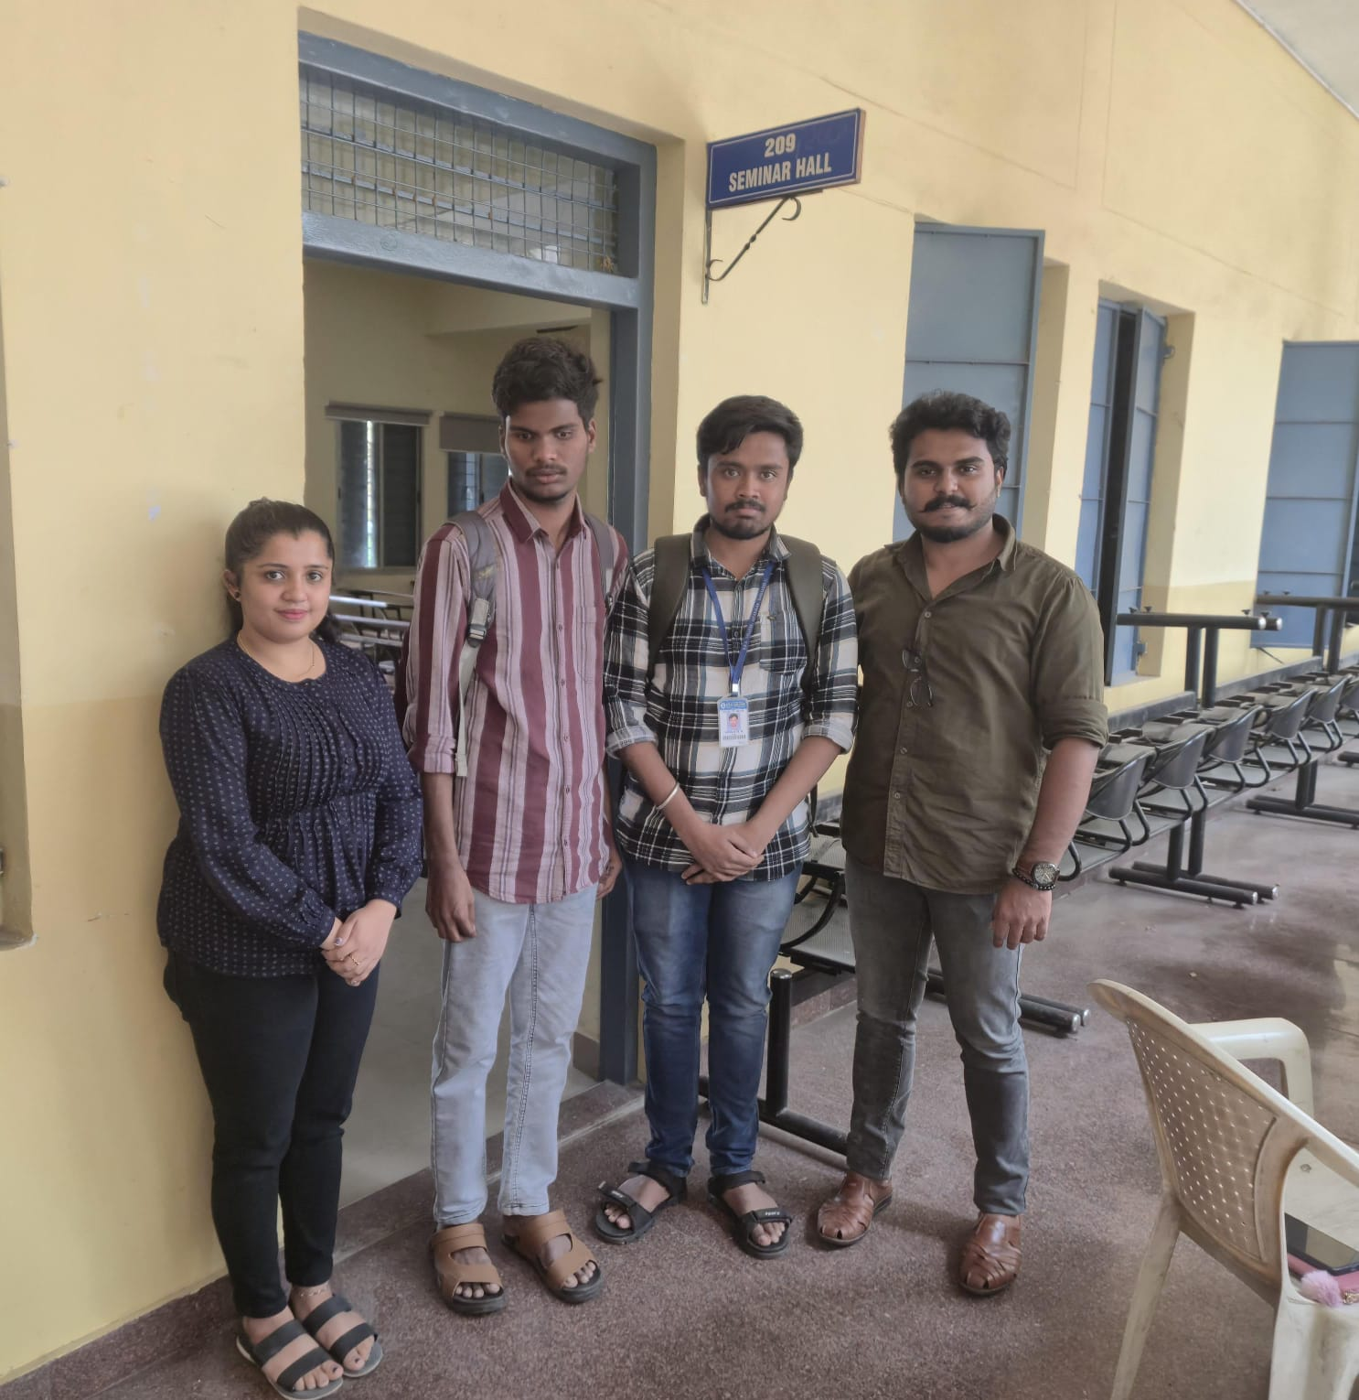

Student name : Ms. Disha Dechamma from 2nd Semester Section A
Date: Saturday, 21st June 2025
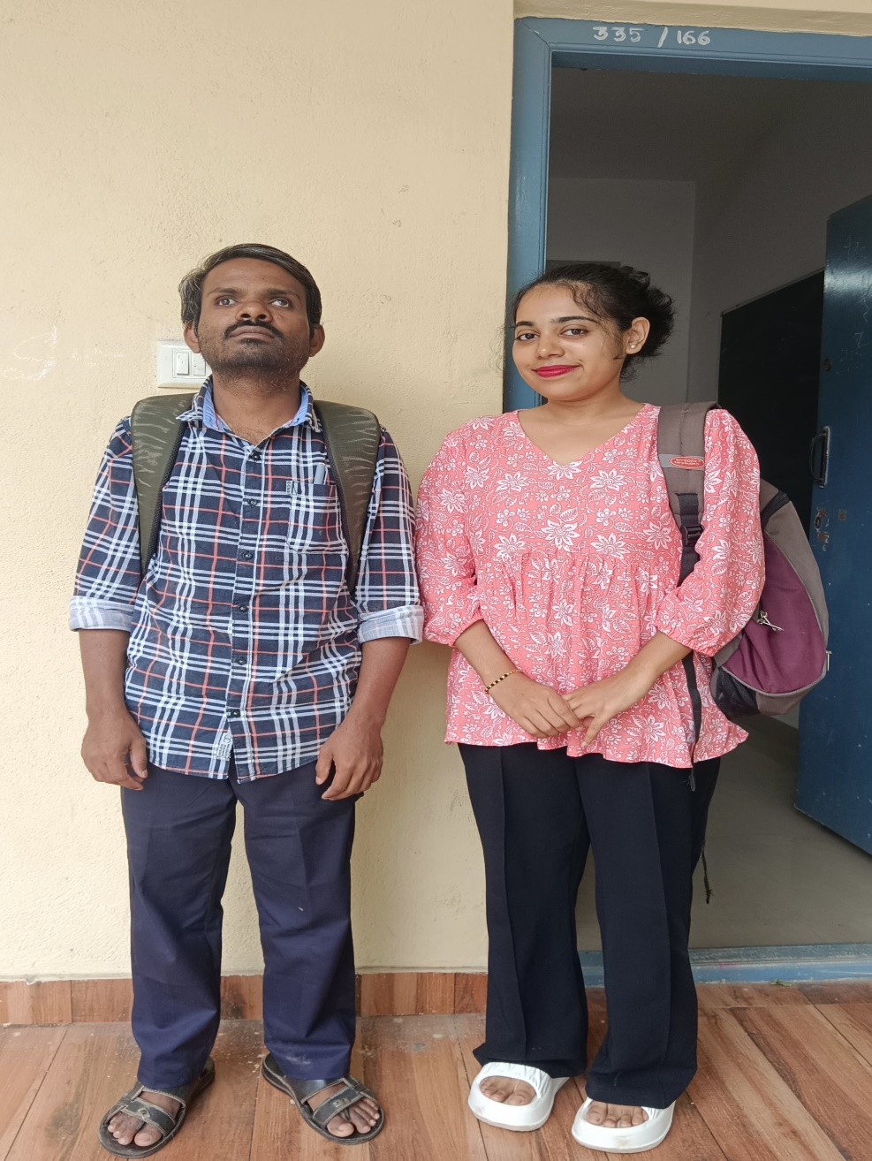

Student name : Ms. Amulya Nagaraj from 2nd Semester Section B
Date: Tuesday, 24th June, 2025
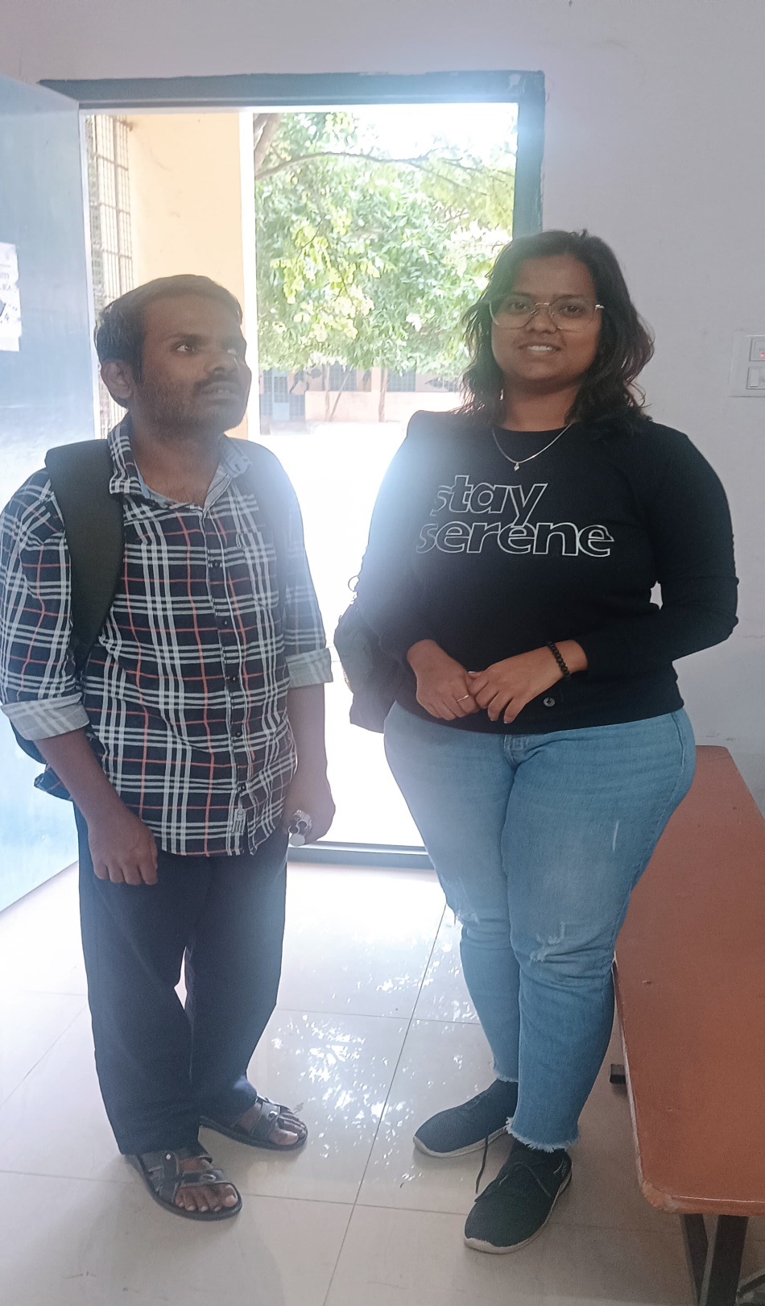

Student name: Mr. Keerthi Raj, 2nd Semester Section C
Date: Thursday, 26th June 2025

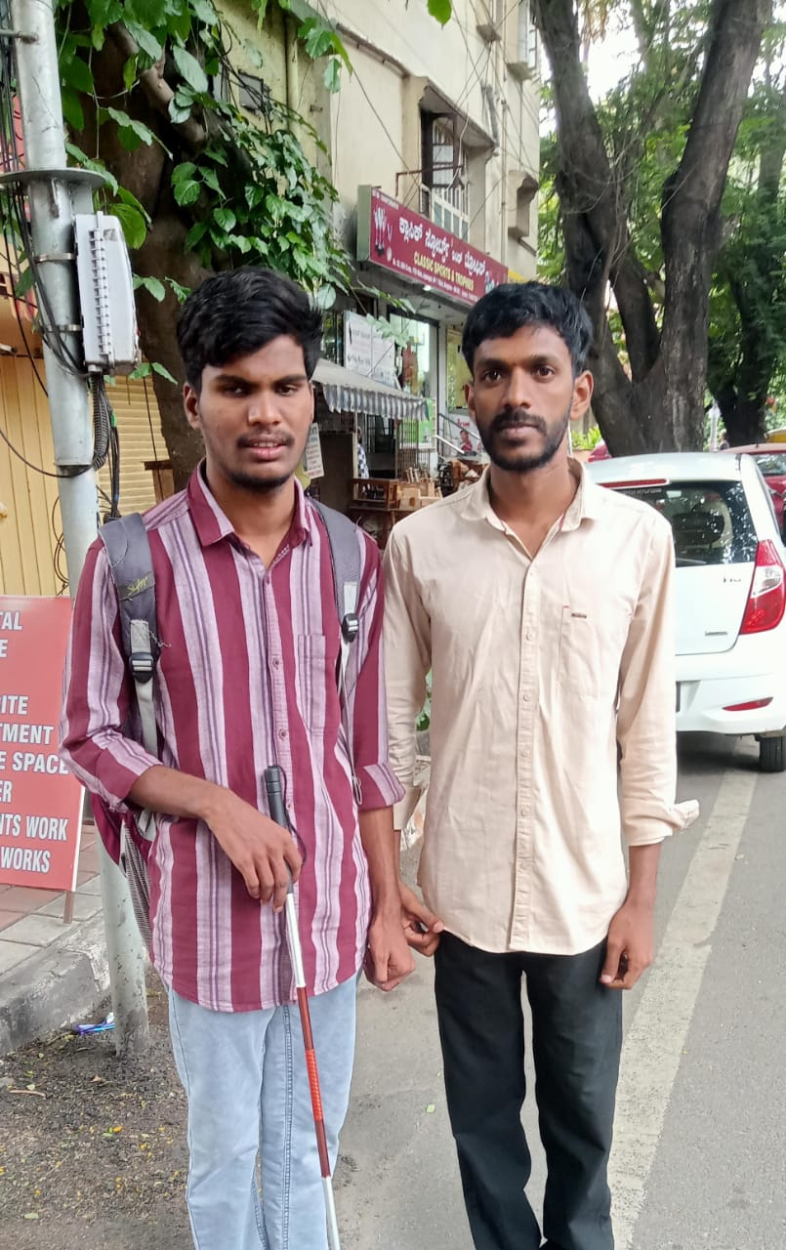

Student name: Ms. Apoorva Mannur, 2nd Semester Section A
Date: Thursday, 26th June 2025
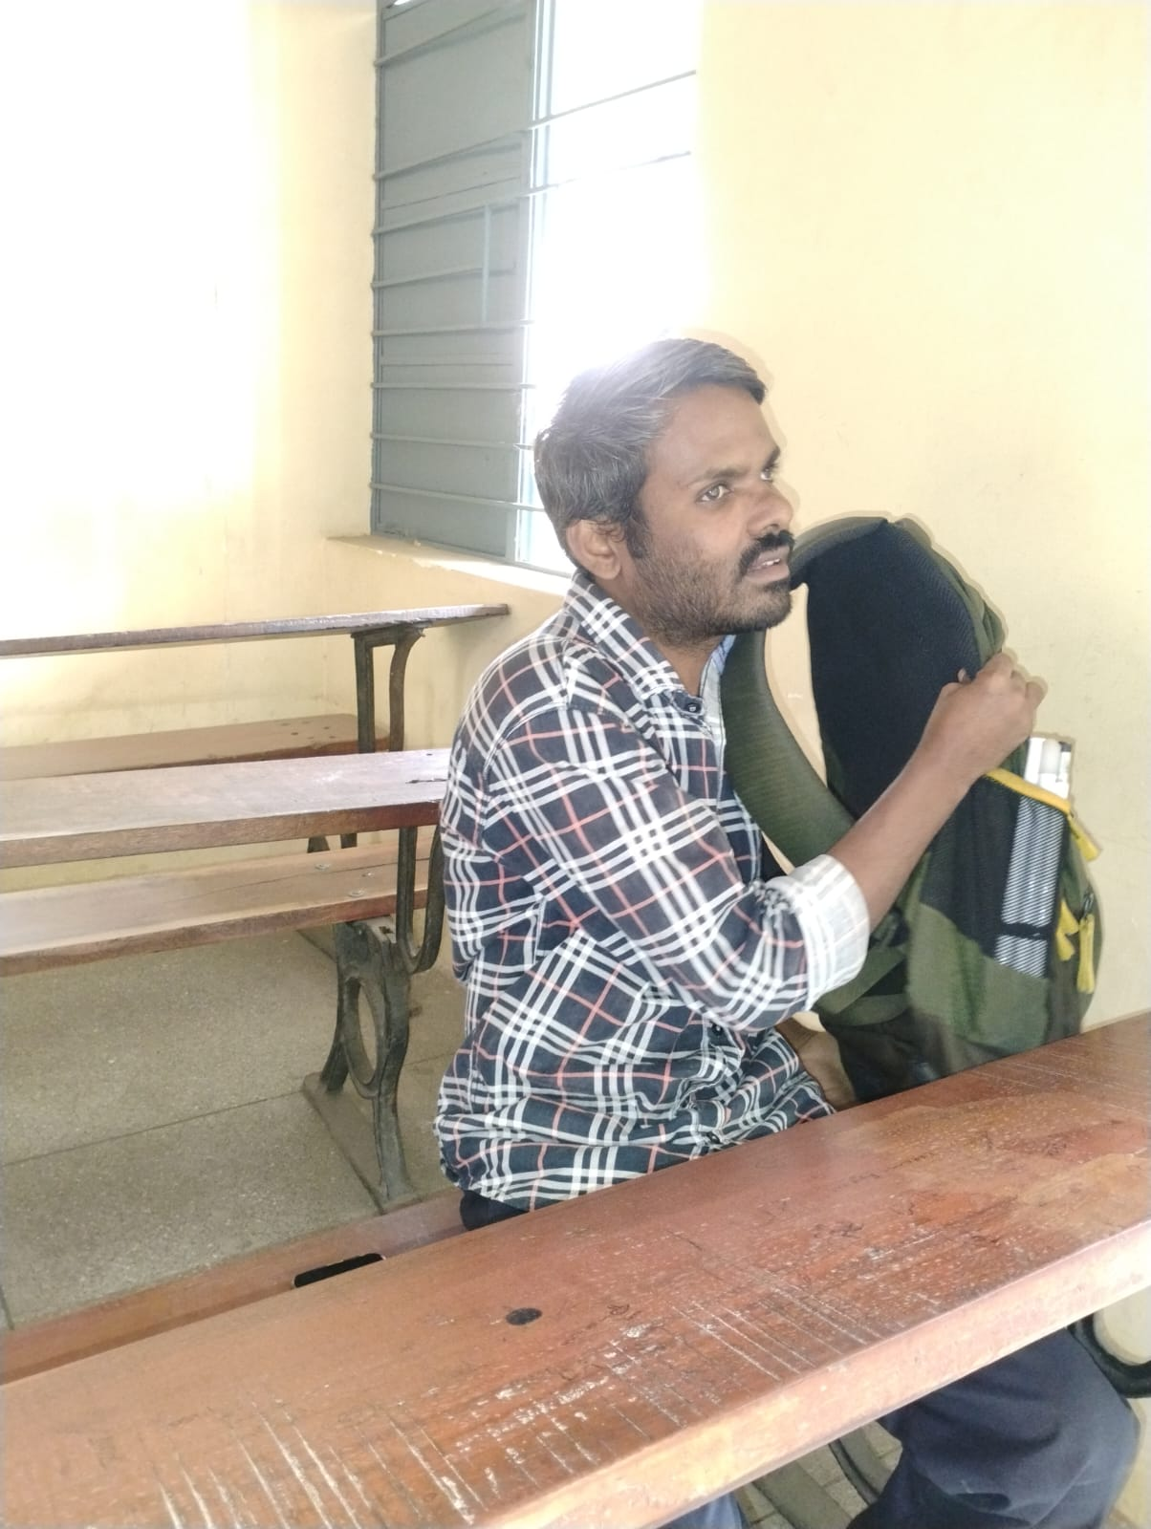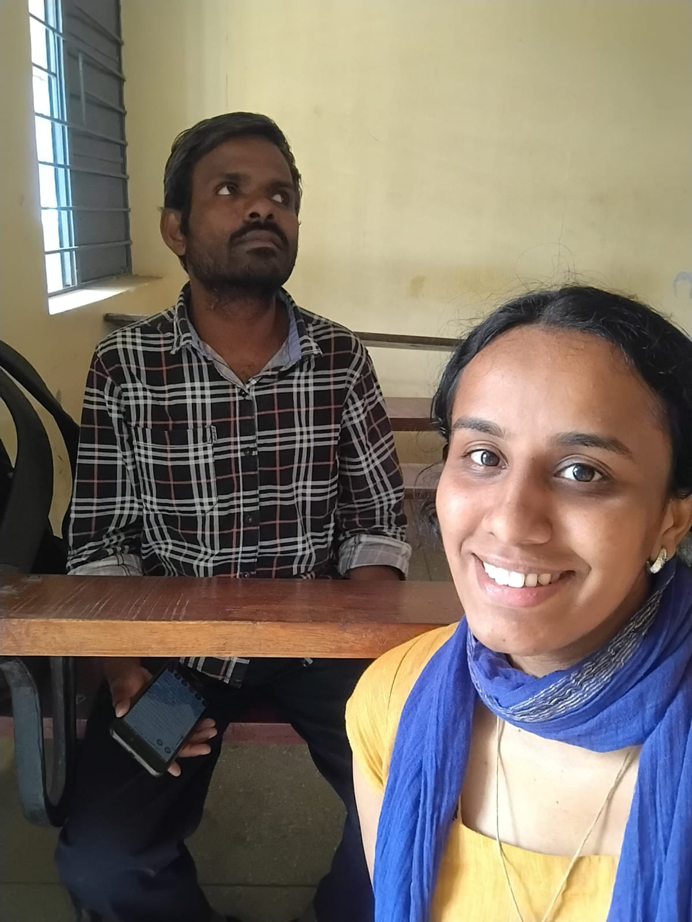

Student name: Mr. Keerthi Raj, 2nd Semester Section C
Date: Saturday, 28th June, 2025
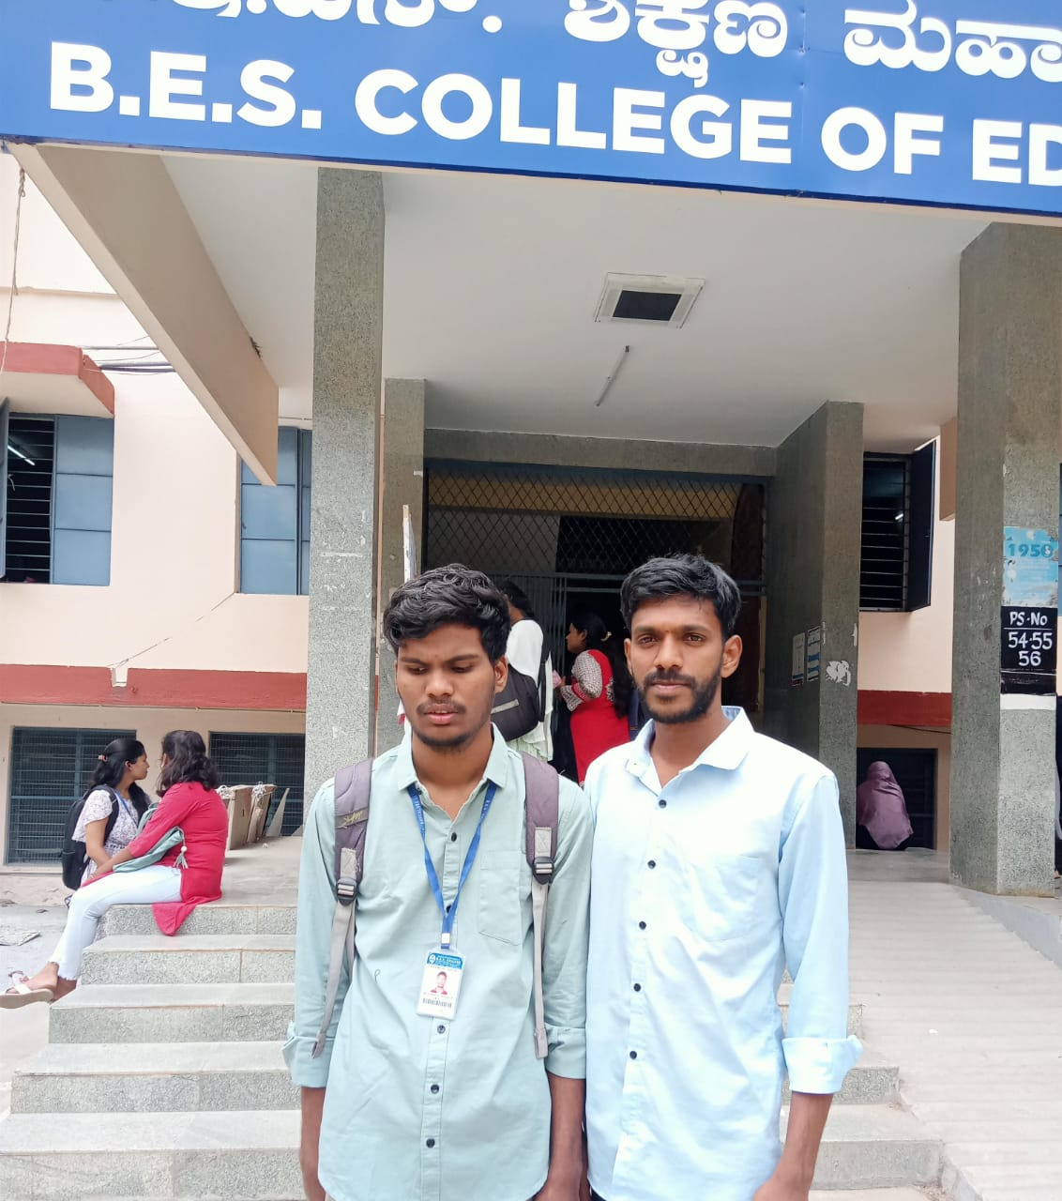

Student name: Ms. Nagashree- 2nd Semester Section C
Dated: Tuesday, 1st July 2025
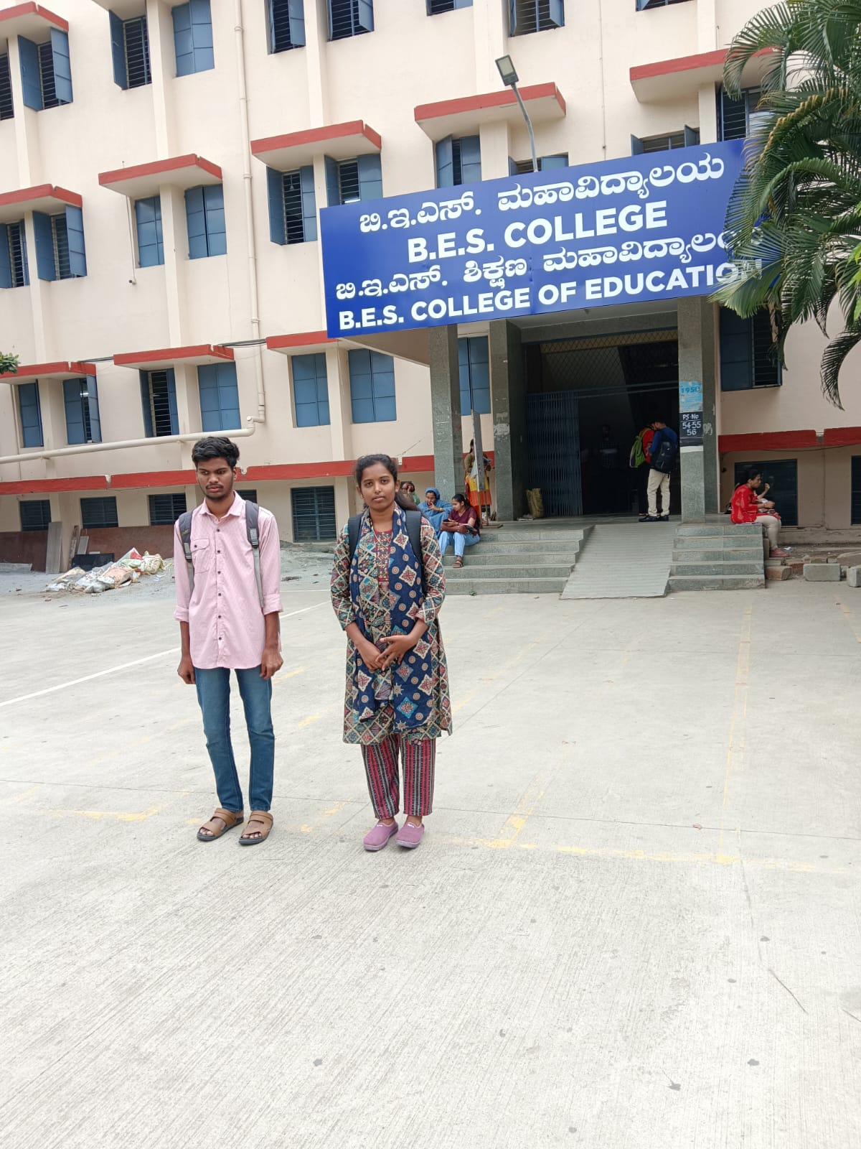

Student name: Ms. Arpitav Subray Bhat, 2nd Semester Section C
Date: Thursday, 3rd July 2025
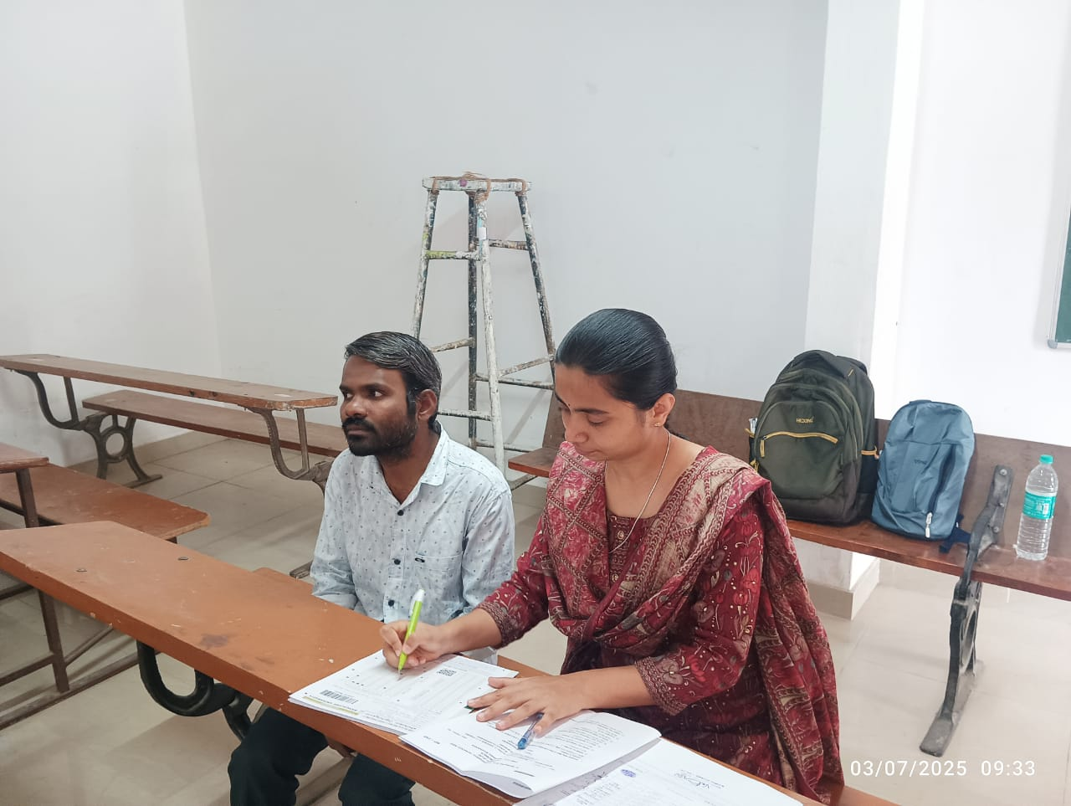

Student name: Mr. Ravikumar, 2nd Semester Section A
Date: Thursday, 5th July 2025
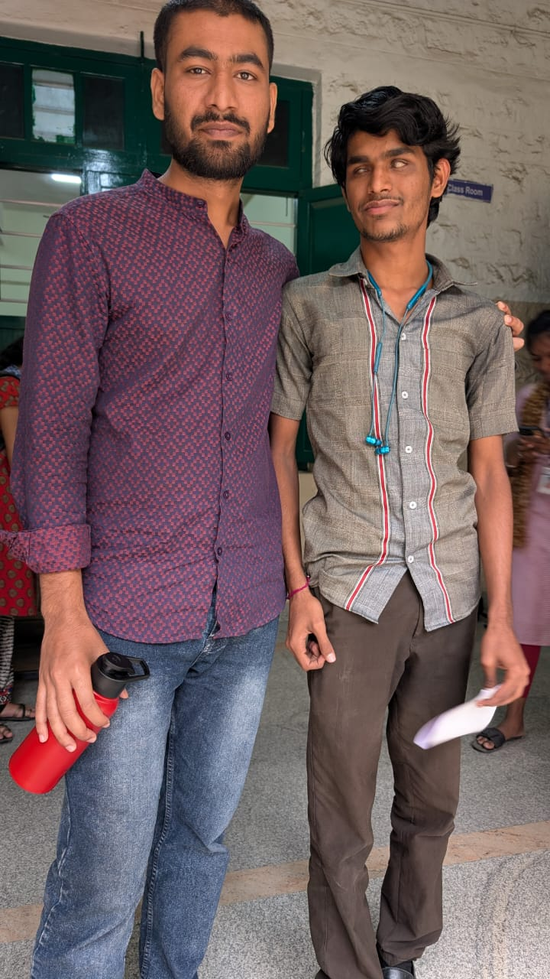

Student name: Mr. Rakshith A, 2nd Semester Section A
Date: Thursday, 8th July 2025
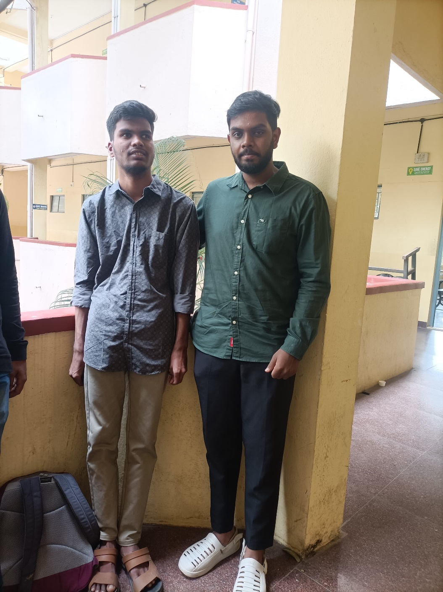

Student name: Mr. Keerthi Raj, 2nd Semester Section C
Date: Thursday, 29th July 2025

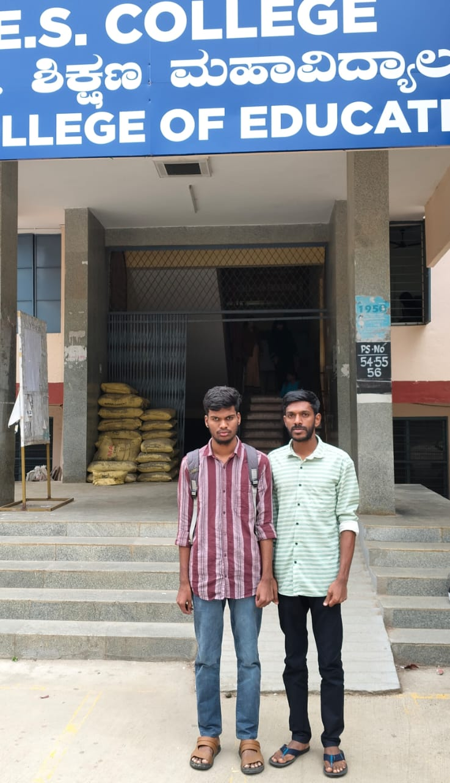


Dr. Purushottam Bung
Director

