7.1.7 Profile of Differently Abled Students

Name: Navyashree M
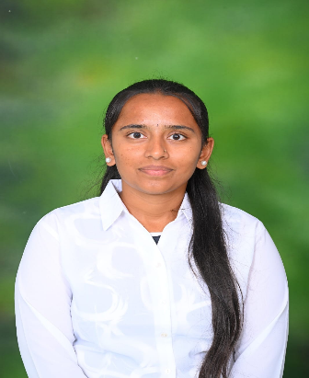
- Date of Birth: 9 July 2003
- Place of Birth: Hullarive, Nelamangala Taluku
- Mobile Number: 8496979519
- Email ID: navyashreemnayana10@gmail.com

Academic Qualifications
Qualification | Year/Month | Percentage/CGPA | Institution
SSLC (10th) | April 2019 | 85.4% | Shree Manjunatha Rural High School, Maralakunte
PUC (12th, Commerce) | July 2021 | 87.6% | Basaveshwara Central PU College, Komala
B.Com | August 2024 | 8.5 CGPA | Malleswaram Ladies Association First Grade College for Women, Malleswaram
MBA (Finance, RVIM) | Still Pursuing | – | RV Institute of Management, Bengaluru

Name: Vinayak Manappa Totad

- Date of Birth: 27 August 2002
- Place of Birth: Magavi Tanda, Gadag
- Mobile Number: 9148121289
- Email ID: vinayaktotad@gmail.com

Academic Qualifications
Qualification | Year | Percentage/CGPA | Institution
SSLC (10th) | 2018 | 86.56% | Bright Horizon School, Kalasapur Road, Gadag (State Board)
PUC (12th, Commerce) | 2020 | 79.16% | A.S.S. PU College of Commerce, Gadag-Betageri (State Board)
B.Com (UG) | 2023 | 78.3% | A.S.S. College of Commerce, Gadag-Betageri (Karnataka University, Dharwad)
MBA (Finance, RVIM) | Still Pursuing | – | RV Institute of Management, Bengaluru

