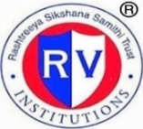 | RASHTREEYA SIKSHANA SAMITHI TRUST  R V INSTITUTE OF MANAGEMENT  CA 17, 26 Main, 36th Cross, 4th T Block, Jayanagar  Bengaluru, Karnataka 560 041 | 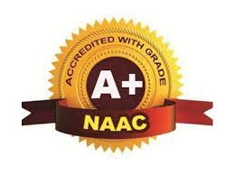

The institute is proactively involved in providing an inclusive environment. The initiatives were taken to promote socio economic well being of students by setting communal harmony. Institute has always been at the forefront of sensitizing students to the cultural, linguistic, communal, and socio -economic diversities of the state and the country.
RVIM collaborated with Aditya Birla Fashion retail ltd to provide free tuition to 10th standard and PUC students every year as part of corporate social responsibility and to provide socio economic wellbeing of underprivileged students.
RVIM celebrates cultural and regional festivals to teach tolerance and harmony to the students. Two important national festivals, Republic Day and Independent Day are celebrated every year in the college.
The institute believes in equality of all cultures and traditions as is evident that students belonging to different caste, religion, regions are studying without any discrimination. The college and its teacher and staff jointly celebrate the cultural and regional festivals, like New-year’s day, teacher’s day, Women’s Day, Yoga day, and also festivals like Ayudh Pooja and Ganesha Festival. In this way the institute's efforts/initiatives in providing an inclusive environment for everyone with tolerance and harmony towards cultural, regional, linguistic, communal socioeconomic, and other diversities.

