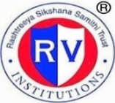 | RASHTREEYA SIKSHANA SAMITHI TRUST  R V INSTITUTE OF MANAGEMENT  CA 17, 26 Main, 36th Cross, 4th T Block, Jayanagar  Bengaluru, Karnataka 560 041 | 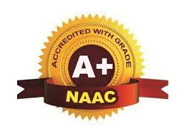
7

7.3 - Institutional Distinctiveness

Health and Wellness Program

Centre for Health and Wellness of RV Institute of Management added health management courses on Yoga practice in its curriculum. The center conducts Yoga sessions for 1st semester students as part of MBA Curriculum as a 2 credit Course. Practice classes are conducted for students every week for two hours. Three batches are conducted for three days in a week. The practice sessions are scheduled between 7.30 am to 9.00am in the morning. Each of these sessions there are instructor guided sessions. According to modern scientists, everything in the universe is just a manifestation of the same quantum firmament science which focuses on bringing harmony between mind and body. Mindfulness and self-care practices through this program can help students alleviate stress while building resilience for the future.

Objective of the Program:
1. Help the students get a holistic view of the yogic way of living, per our scriptures.
2. Instil our young minds with the awareness & benefits of a strong mind and body.
3. Promote focus on understanding the scientific knowledge for enhanced benefits behind the healthy living

