Report on Felicitation of Case Study Challenge Winners at RV Institute of Management, Bangalore
Date: November 26th, 2024. | Venue: Conference Hall, RVIM, Bangalore.
Time: 11.00 am to 11.45 am | Event : Felicitation Programme
No. of Participants: 120 | Event Coordinators: Prof. Pooja T
RV Institute of Management (RVIM), Bangalore, witnessed an exciting and prestigious moment as two of its students were felicitated for their exceptional performance in the National Level Case Study Challenge conducted by Business Standard. The event was held to honour the winners of this highly competitive contest, which was centered around the B-Smart Application launched by Business Standard.
The B-Smart Application, an innovative initiative by Business Standard, seeks to provide real-time business news, cases, insights, analysis, job opportunities and quizzes. The case study challenge invited MBA students from across India to analyze a case on the app which was on the topic of “Work Life Balance”, its impact on individual and corporate growth, and propose solutions for its future enhancement. With students from various prestigious institutions competing, RVIM students shone brightly, securing the First and Second prizes. Miss Sadiya Khudeja bagged the first prize, while Mr. Mark Dakshin Kennedy bagged the second prize.
The felicitation ceremony took place at RVIM as the students, faculty members, and representatives from Business Standard, all gathered to celebrate the accomplishments of the winners. Mr. Jayaram, from Business Standard, graced the occasion and presented the winners with their awards. Along with the certificates of achievement, both winners were presented with cash prizes as recognition of their outstanding contributions to the competition. Dr. Purushottam Bung, Director of RVIM, also participated in the felicitation. He spoke highly of the students' achievements, emphasizing the importance of practical learning, analytical skills, and the application of theoretical knowledge in real-world scenarios. Dr. Bung congratulated the winners and encouraged all students to take such opportunities.
Following the felicitation, both winners shared their experiences of participating in the challenge. Sadiya and Mark spoke about the research, the challenges they faced, and how the competition helped them sharpen their skills in strategic thinking and business analysis. They also expressed their gratitude to the faculty at RVIM for their guidance and support throughout the preparation phase. The National Level Case Study Challenge organized by Business Standard was a great success, particularly for RV Institute of Management, which saw its students excel in a highly competitive environment. The felicitation ceremony highlighted the achievements of the winners, Miss Sadiya Khudeja and Mr. Mark Dakshin Kennedy, both of whom are second-year MBA students at RVIM. Their remarkable performances in the case study challenge have brought pride to the institution, showcasing the caliber and expertise nurtured at RVIM. The event was not only a moment of celebration for the winners but also an inspiration for other students to actively participate in such challenges. RVIM, with its focus on academic excellence and industry-oriented learning, continues to foster a learning environment that equips students to succeed in the business world. This achievement stands as a testament to the growing reputation of RVIM and its commitment to producing industry-ready professionals. The institute congratulates the winners once again and looks forward to more such successes in the future.
Photos of felicitation
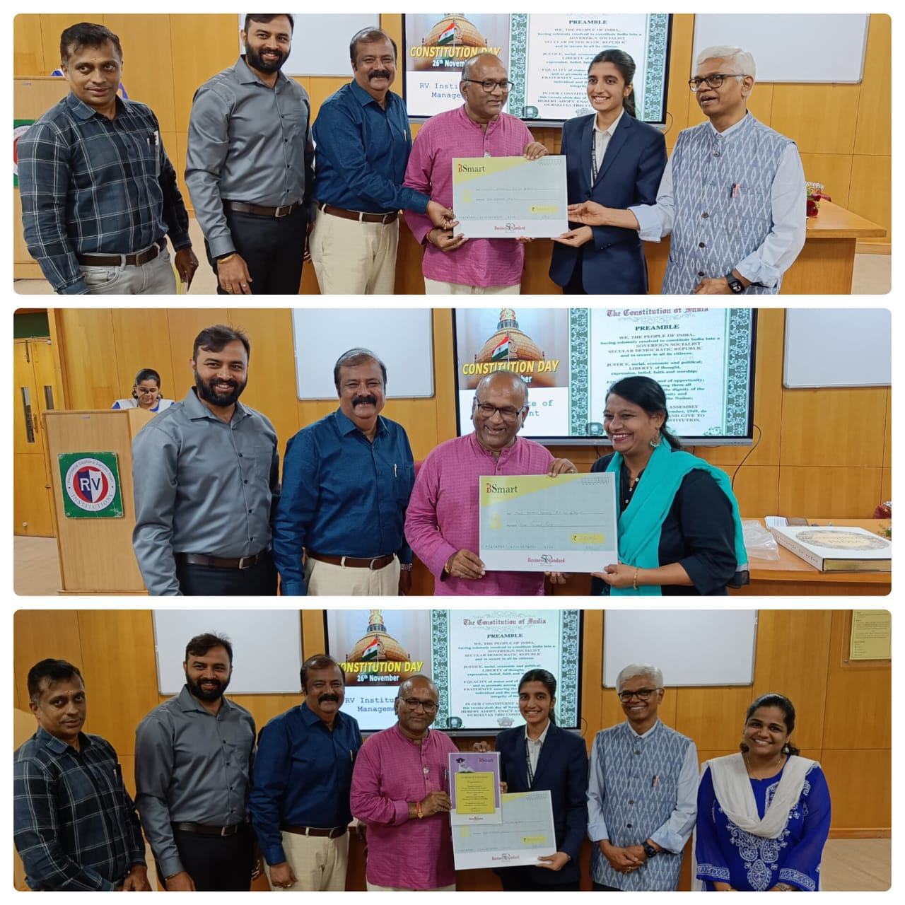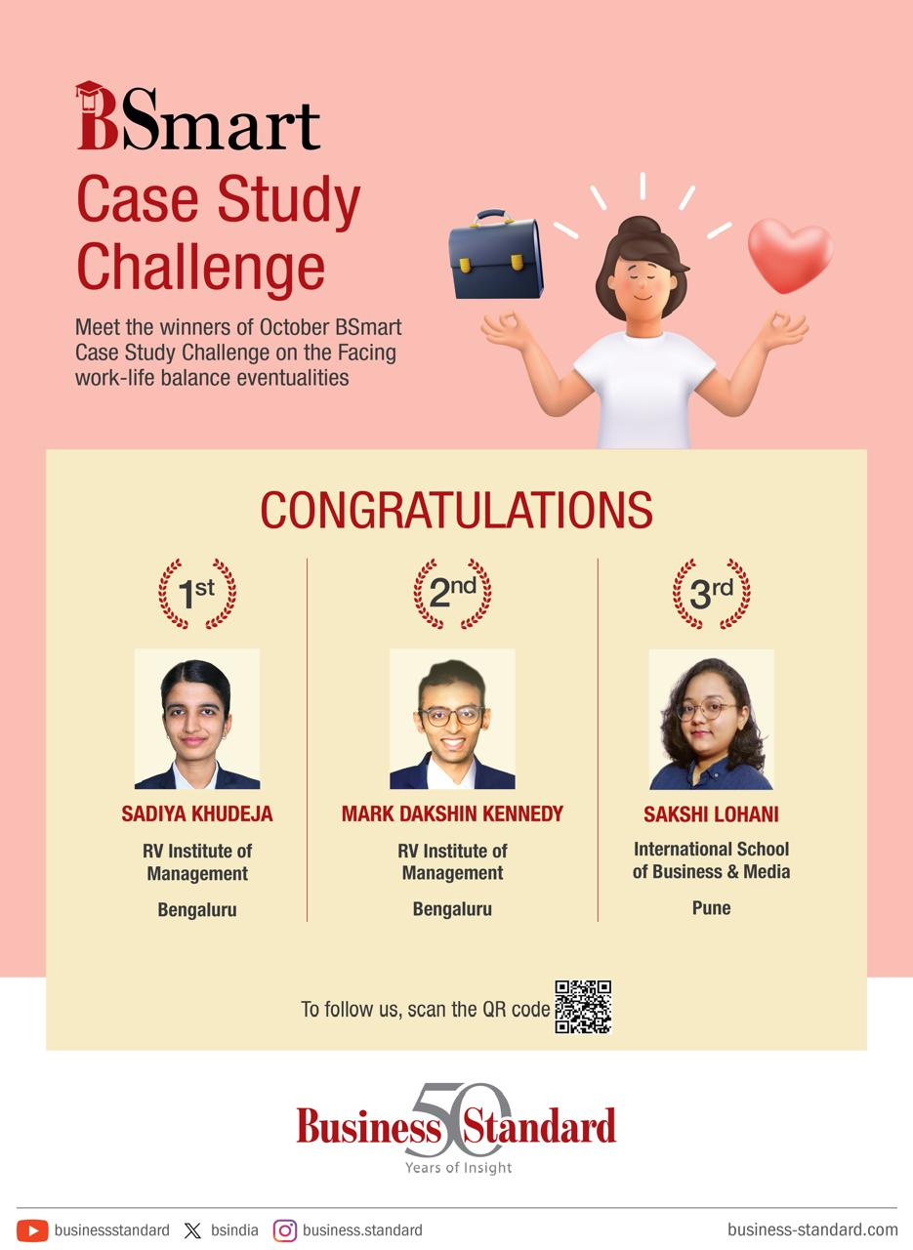
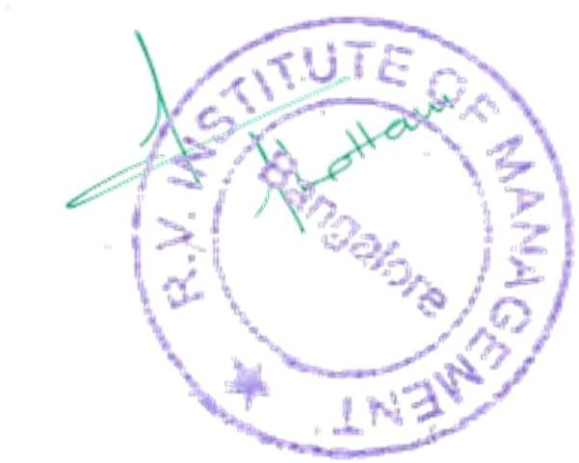





Director, RVIM.
CA 17, 36th Cross Rd, 26th Main, 4th T Block East
Bengaluru - 560041, Karnataka, India
080 42540300
080 26547048
www.rvim.edu.in
Scan Here

