Circular
Ref. No.: RVIM/CoC/2025/01 Date: 23rd April 2025

This is to inform all concerned that a meeting of the Committee for Code of Conduct will be held on Thursday, 24th April 2025, at 4:15 PM in the Board Room, RVIM, to review the implementation of the Institute's Code of Conduct.
The following agenda items will be taken up during the meeting:

1. Review of specific areas of the Code of Conduct that are being implemented effectively, with particular focus on student discipline, on-campus behavior, and consequences for violations.

2. Deliberation on strengthening the positive aspects of the existing Code of Conduct and identifying areas requiring further improvement.

3. Discussion of feedback received from students, parents, faculty, and staff during the orientation program, and ensuring that the Code of Conduct reflects the expectations and values of the entire educational community.

All members of the Committee are requested to make it convenient to attend the meeting without fail. Members are encouraged to come prepared with their inputs and suggestions on the above agenda points.
Your cooperation in this regard is highly appreciated.
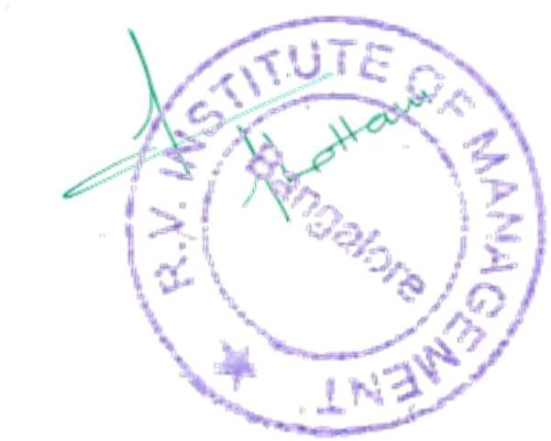

Dr. Purushottam Bung
Professor and Director
RV Institute of Management, Bangalore

Copy to:
1. Dr. Anupama K Malagi, Professor, RVIM
2. Mr. Manjunath M, Assistant Professor, RVIM
3. Ms. Rashmi Shetty, Assistant Professor, RVIM
4. Notice Board

