Report on Fresher’s Day 2025
Abhyudaya
Date: 25-01-25 | Venue: RVIM Quadrangle
Time: 10AM | Event : Fresher’s Day 2025- Abhyudaya
No. of Participants: 180 | Event Coordinators: Prof. Pooja T.
Abhyudaya 2025, the Freshers’ Day celebration of RV Institute of Management, was organized with great enthusiasm to welcome the freshers’ batch of 2025. The event aimed to provide a platform for new students to interact, showcase their talents, and begin their academic journey in a vibrant and inclusive environment. The event played a significant role in easing the transition of freshers into campus life by encouraging interaction, confidence building, and teamwork. Abhyudaya 2025 was meticulously planned and well-organized by the faculty members and student coordinators, ensuring seamless execution of all activities. The disciplined management, vibrant coordination, and enthusiastic participation made the celebration a grand success and a memorable beginning for the freshers at RV Institute of Management.

The program was marked by a series of fun-filled games and engaging competitions, which helped break the ice and foster bonding among students. Various cultural events such as dance, music, and performance-based activities were conducted, allowing the freshers to express their creativity and confidence.

One of the major highlights of Abhyudaya 2025 was the Mr. and Ms. Fresher competitions, where participants were judged on personality, talent, confidence, and stage presence. The event concluded with the announcement and awarding of Mr. Fresher, Ms. Fresher, and Best Section, recognizing excellence, participation, and team spirit among the students.

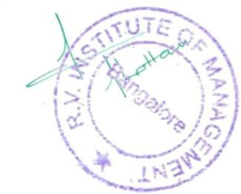
The celebration was filled with joy, laughter, and positive energy, creating lasting memories for the freshers. Abhyudaya 2025 successfully set the tone for a promising academic year by promoting unity, enthusiasm, and a sense of belonging within the RV Institute of Management.
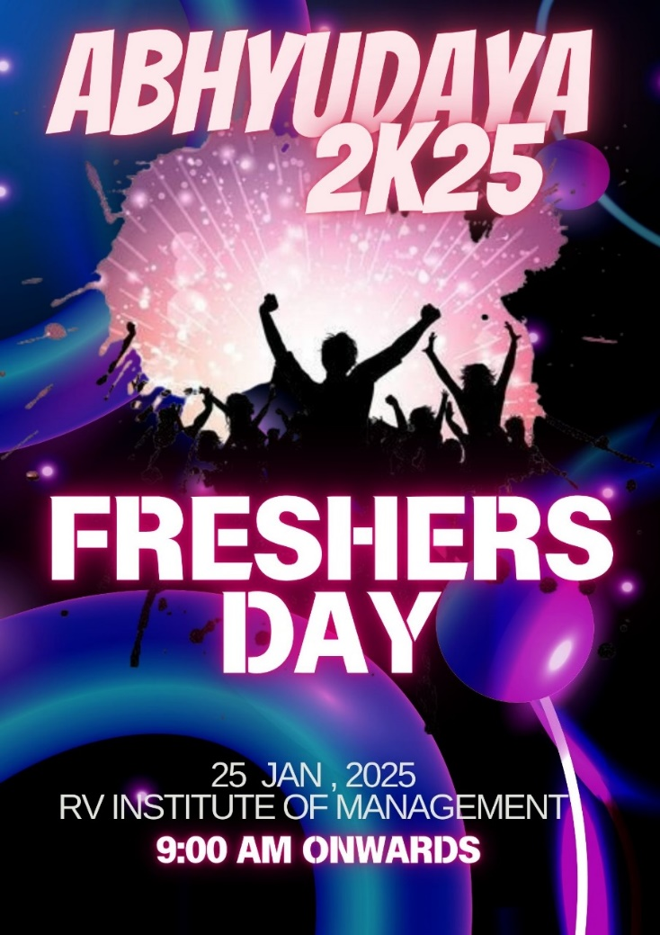

Fresh beginnings, new faces, and boundless enthusiasm marked the Freshers’ Day celebration held on 25th January 2025. The campus came alive with vibrant energy as senior students warmly welcomed the new batch into the academic family, making the day a beautiful blend of excitement, bonding, and unforgettable memories.

PHOTO GALLERY:

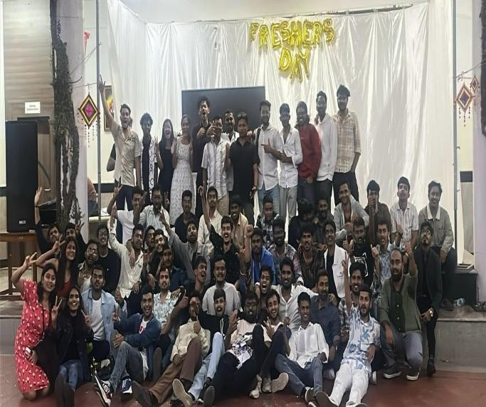 | 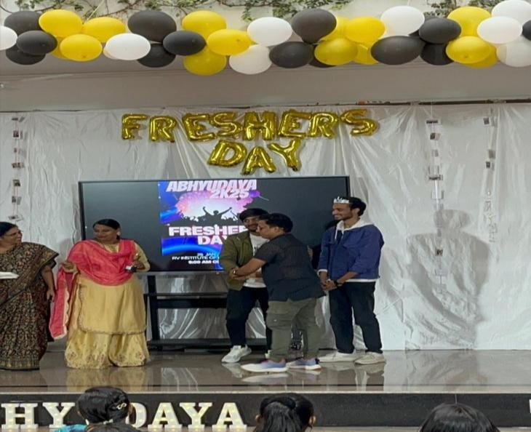
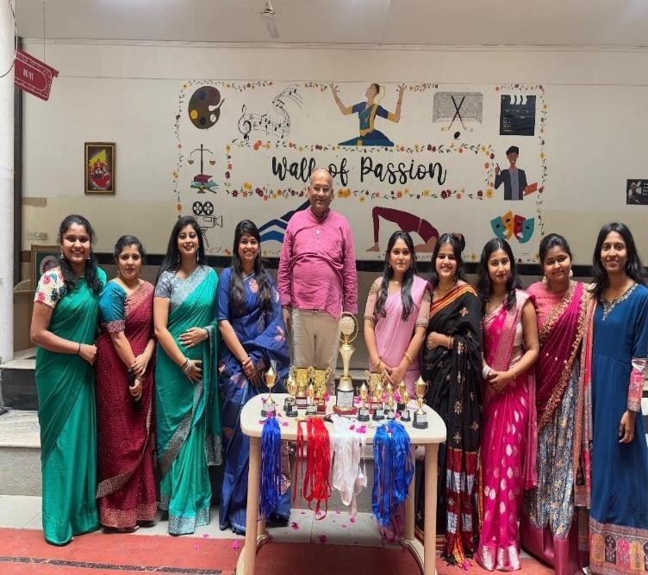 | 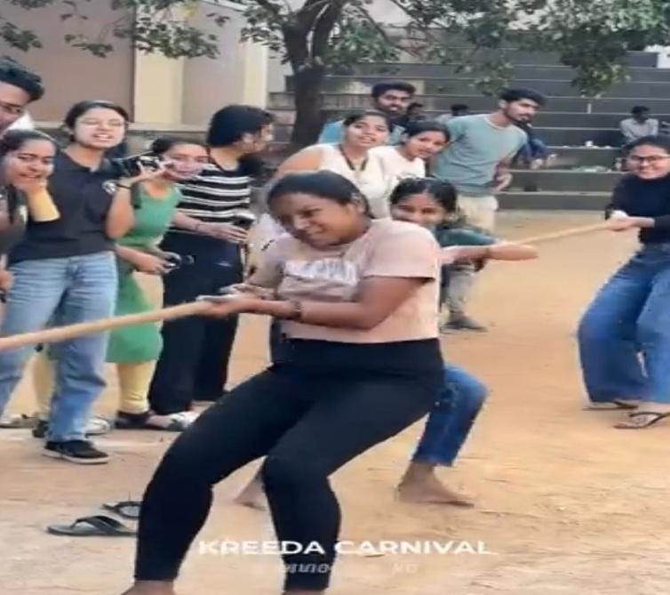


Event Co-ordinator Director

