
RV INSTITUTE OF MANAGEMENT
(Autonomous Institution Affiliated to BCU, Approved by AICTE, New Delhi)
4th Block, Jayanagar Bengaluru-560041, Karnataka.

COURSE DOCKET -IV SEMESTER MBA
21MBA241-INTERNATIONAL BUSINESS

June 2025-August 2025
COURSE FACILITATORS
Prof. CS Venkatesh
Prof. Anitha BM D’silva
Dr. Uma Sharma
Department of Marketing
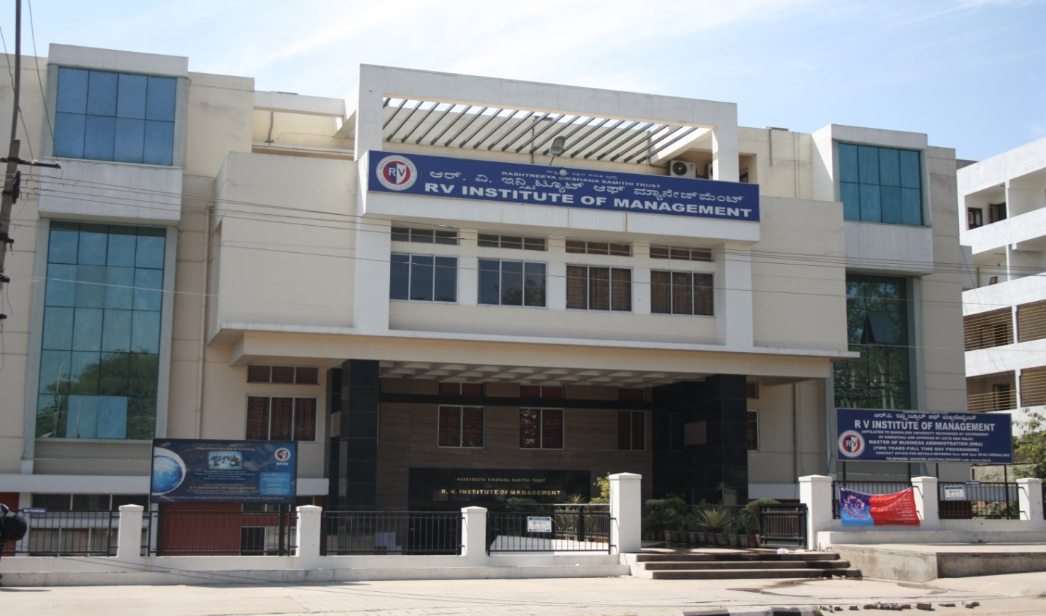
The articles and reading materials contained in this docket are for classroom discussion only

Course | MBA programme
Batch | 2023-2025
Semester | IV
Subject Name | International Business
Credits | 4 credits
Total hours | 36 hrs

Subject Name: International Business

Subject Code: 21MBA241

Semester: 4th
Syllabus
Introduction:
International Business encompasses all those business activities that involve crossborder transactions of goods; services and resources between two or more nations. The transactions of economic resources include capital; skills; people; etc.; for the international production of physical goods and services such as finance; banking; insurance and construction. This course is a comprehensive outlook which includes latest development on the frontiers of knowledge providing the insights of International Business and its dimensions. The objective of the course is to expose the students to the concept; versatility and dynamics of International Business. It aims at familiarizing the students with business environment at the International level including Institutions and agreements.
Course Outcomes (COs): Having successfully completed this course student will be able to:
CO1: Describe the relationships between international business and the political; economic; legal and social policies of countries; regions and international institutions.
CO2: Comprehends the complexities of international business both home country and host country.
CO3: Understand and appreciate the impact of functioning of international organizations and trading blocks in the global economy
CO4: Analyze the role and impact of international theories on International Business
CO5: Explore the various contemporary developments in the field of international Business.

Pedagogy:
• Classroom discussion
• Case based teaching
• Project based teaching
• Experiential learning
• Interactions with the experts in IB
Teaching Learning Resources:
Essential readings
1. Francis Cherunilam; International Business; Prentice Hall of India.
2. Charles Hill; International Business; McGraw-Hill-Irwin.
3. K Ashwatappa; International Business; Tata McGraw-Hill education
4. John D. Daniels; Lee Radebaugh and Daniel P. Sullivan; ―International Business‖; Prentice Hall.

Case Studies – Word file International Business
- Crossing Borders -(Underlying Forces Of International Business)
- Case On Cross-Cultural Management By Katherine Xin and Wang Haijie
- Case Reading--World Goes Banana
- JAPAN—Test Market For The World-Market Research For International Business
- Selling Coffee In Tea-Drinking Japan-(Case Reading For New Product Development For Global Market)
- South Korean Car Manufacturer-Daewoo Motors
- Emerging Marketing Opportunities And Challenges In South Asia
- Channels Of International Distribution For Floriculture- Chandrika Flora
- Offers turn down
- P & G Fiasco
REFERENCES
1. Richard M Hodgetts and Fred Luthans; ―International Management‖; McGraw-Hill;
2. Hill; C.W.L. and Jain; A.K.; International Business: Competing in the Global
3. Marketplace; 6th Edition; Tata McGraw-Hill Education;
4. Paul; J.; International Business; 5th Edition; PHI Learning;
5. Ball; D.; Geringer; M.; Minor; M. and McNett; J.; International Business: The
6. Challenge of Global Competition; Tata-McGraw-Hill Education;
7. Deresky; H; International Management: Managing Across Borders and Cultures; 6thEdition; Pearson.
8. Griffin; R.; International Business; 7th Edition; Pearson Education.
9. Anant K Sundaram &J Stewart Black; The International Business Environment; Prentice Hall Of India.
10.Tayeb; Monis H: The Global Business Environment – An Introduction; Sage Publication; New Delhi.
11. Francis Cherunilam; International Business Environment; Himalaya Publishing House.

Supplementary Reading:
  - https://jgateplus.com/search/login/
  - https://www.ebsco.com/products/research-databases/hbr-ascend
  - http://elibrary.in.pearson.com/
  - https://onlinecourses.nptel.ac.in/

CO-PO Mapping:
 | PO1 | PO2 | PO3 | PO4 | PO5 | PO6 | PO7 | PO8
CO1 | 3 | 1 | 1 | 3 | - | 2 | - | -
CO2 | 3 | - | 1 | - | 1 | - | - | 3
CO3 | 3 | - | - | - | - | - | - | 1
CO4 | 3 | 1 | - | 1 | - | 3 | 2 | 1
CO5 | 2 | 1 | - | 1 | - | 1 | 3 | 1
LEVEL 3-Substantial 2-Moderate 1-Slight - No relation

EVALAUTION PLAN
SL NO | PARTICULARS |  | MARKS
1 | SEMESTER END EXAMINATION | Marks | 50
2 | CIA
 | Attendance and class participation | 05
 | Mid term examination | 20
 | Capstone Pestle/ Assignments Report and Presentation | 20
 | Coursera Course compulsory | 05 | 50
 | Total |  | 100

EVALUATION PLAN-
Topics/ Content | Marks
1.Capstone Pestle Analysis of a country/ Assignments, Report and Presentation | 20
2. Course-sera Course compulsory | 05
Elaborating on the Content
1.Capstone Pestle Analysis of a country/ Assignments, Report and Presentation- individual  The student has to choose a country and take up the PESTLE analysis and understand the environment. OR The topics that are given below can be taken for submission of the assignment.  Submission:  Soft bounded report of the PESTLE/ Assignment-10 marks  Presentation in the class -10 marks  Presentation is done by the students  Topics for Assignment  a. Make in India - Sell Everywhere: What are the key challenges and opportunities  b. Negotiating Agreements: Indian Style vs. Western Style  c. Protectionism vs. Free Trade: India's Balancing Act  d. Why Do Foreign Companies Invest in Bangalore (FDI Inflows)? Why can't we attract higher investments?  e. The Impact of Global Sanctions and Geopolitical Tensions on Indian Business  f. Ethical Dilemmas in Global Business: Child Labor, Environmental Standards  g. India's FTA Strategy: Beneficial or Inimical for Local Industries?  h. The BRICS Influence: India's Role in a Changing Global Order  i. "Make in India" and Global Supply Chains - how do we fare against competing countries?  j. Digital Divide vs. Digital Opportunity: E-commerce and Remote Work in a Globalized World | 20 Marks
2. Coursera course- Fundamental of International Business- University of London  Submission: Individual certificate  Grade given based on the knowledge gained and actual grade scored by the student  1.https://www.coursera.org/learn/fundamentals-of-international-business | 5 marks

EXPERIENTIAL LEARNING ACTIVITY - EXTEMPORE SESSION ISSUES IN IB
Meaning: Extempore is done without any preparation on the spot or a little. Hence this activity is given to students to present their ideas on stage. Each student should speak for 2 minutes. For Each topic 2 students will be speaking One For the topic and one Against the topic. Students will be randomly picked from the student’s pool list. 1ST week oof June the topics will be circulated and the 2nd week the event will be taking place in seminar hall.

Rubrics for Assignment/ PESTLE
Grading criteria | 9-10  Excellent | 7-8  Good | 4-6  Met Expectations | 1-3  Below Expectations | O  Not Submitted
Professional documentation of the assignment | Excellent professional documentation according to the topics given, greater binder and appearance | Good professional documentation according to the topics given, average binder and appearance | Satisfactorily documentation according to the topics given, average binder and appearance | Some efforts in professional documentation needed, substandard physical appearance | Failed
Content Completion | The report contains 90% and above data related to the topic chosen, sufficient research has been done | The report contains 60-89% and above data related to the topic chosen, sufficient research has been done | The report contains 30-59% and above data related to the topic chosen, sufficient research has been done | The report contains very minimal research related to the topic chosen, | Failed
Contents Accuracy | Excellent coverage of information related to country with the deliverables and impeccable accuracy | Good coverage of information related to country with the deliverables and substantial accuracy | Insufficient coverage of information related to country with the deliverables and limited accuracy | Limited t coverage of information related to country and no accuracy | Failed
Formatting | Excellent formatting, data collection, writing and language | Good formatting, data collection, good writing and language | Needed more efforts in formatting, data collection, efforts in writing and language | Efforts are in-sufficient and no data is properly collected, language is poor. | Failed
Time and efforts spent in data collection and reading | Significant reading has been done about the country. The journals and articles have been referred during the period | Sufficient of reading has been done about the country. The journals and articles have been referred during the period. | In-Sufficient reference to journals and articles during the period of assignment | Poor reference to journals and articles during the period of assignment | Failed

-xx-

