
RV INSTITUTE OF MANAGEMENT
(Autonomous Institution Affiliated to BCU, Approved by AICTE, New Delhi)
4th Block, Jayanagar Bengaluru-560041, Karnataka.

COURSE DOCKET -IV SEMESTER MBA
21MBA241-INTERNATIONAL BUSINESS

June 2025-August 2025
COURSE FACILITATORS
Prof. CS Venkatesh
Prof. Anitha BM D’silva
Dr. Uma Sharma
Department of Marketing
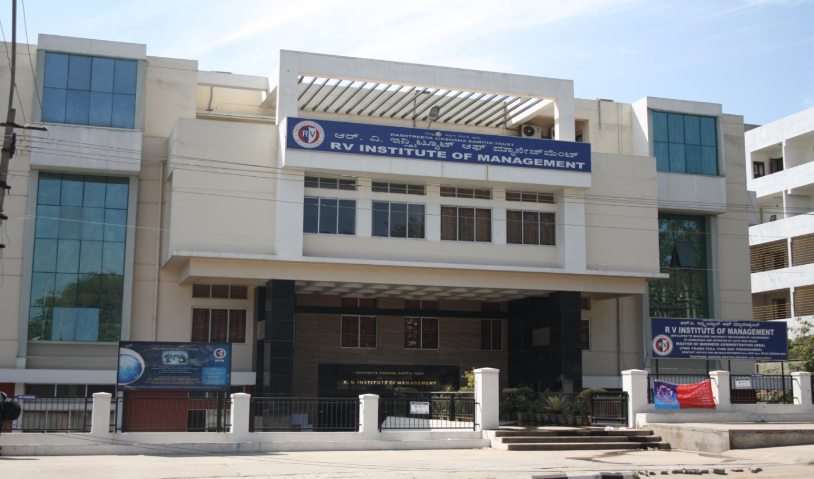
The articles and reading materials contained in this docket are for classroom discussion only

Course | MBA programme
Batch | 2023-2025
Semester | IV
Subject Name | International Business
Credits | 4 credits
Total hours | 36 hrs

Part C- Syllabus
Introduction:
International Business encompasses all those business activities that involve crossborder transactions of goods; services and resources between two or more nations. The transactions of economic resources include capital; skills; people; etc.; for the international production of physical goods and services such as finance; banking; insurance and construction. This course is a comprehensive outlook which includes latest development on the frontiers of knowledge providing the insights of International Business and its dimensions. The objective of the course is to expose the students to the concept; versatility and dynamics of International Business. It aims at familiarizing the students with business environment at the International level including Institutions and agreements.
Course Outcomes (COs):
Having successfully completed this course student will be able to:
CO1: Describe the relationships between international business and the political; economic; legal and social policies of countries; regions and international institutions.
CO2: Comprehends the complexities of international business both home country and host country.
CO3: Understand and appreciate the impact of functioning of international organizations and trading blocks in the global economy
CO4: Analyze the role and impact of international theories on International Business
CO5: Explore the various contemporary developments in the field of international Business.

Course content and Structure: (36 hours)
Module 1: Introduction to International Business 10 Hours ⎯
Introduction to International Business; ⎯ Elements of International Business; Globalization; Modes of Foreign Entry⎯ International Business Environment - Economic Environment; Political Environment; Demographic environment; Legal Environment ⎯ Culture in an International Business Organization.
Module 2: International Trade theories and their application: 04 Hours − Introduction to International Trade theories ⎯ Why do nations trade ⎯ Theories of International trade- mercantilism; Absolute advantage; Comparative advantage; Heckscher- Ohlin; Product life cycle theory and Porter’s diamond model. ( Theories, its advantages and disadvantages)
Module 3: Export Import Procedures and Ethics in IB 10 Hours ⎯ Documentation in international trade ⎯ Export contract ⎯ Export order processing ⎯ Methods of payment in international trade ⎯ Main Provisions of FEMA ⎯ Procedure and documentation for availing export incentives. ⎯ Ethics in International Business ⎯ Code of conduct for MNCs
Module 4: Regional integration and Global trade institutions 08 Hours ⎯ Regional integration: Introduction ⎯ Overview of Regional Integration ⎯ Types of Integration ⎯ Regional Trading Arrangements ⎯ India and Trade Agreements ⎯
Global trade institutions: Introduction ⎯ World trade organization (WTO) ⎯ International Labour Organization (ILO) ⎯ International Monetary Fund (IMF) and ⎯ World Bank
Module 5: Contemporary development in International Business 04 Hours ⎯ Foreign investments (FDI, FII, Routes of FDI⎯ Crypto currency ⎯ Bit coin ⎯ Global Sourcing ⎯ Technology transfers ⎯ Global operations management ⎯ International company structure ⎯ Global pricing strategy

Pedagogy:
• Classroom discussion
• Case based teaching
• Project based teaching
• Experiential learning
• Interactions with the experts in IB
Teaching Learning Resources:
Essential readings
1. Francis Cherunilam; International Business; Prentice Hall of India.
2. Charles Hill; International Business; McGraw-Hill-Irwin.
3. K Ashwatappa; International Business; Tata McGraw-Hill education
4. John D. Daniels; Lee Radebaugh and Daniel P. Sullivan; ―International Business‖; Prentice Hall.
REFERENCES
1. Richard M Hodgetts and Fred Luthans; ―International Management‖; McGraw-Hill;
2. Hill; C.W.L. and Jain; A.K.; International Business: Competing in the Global
3. Marketplace; 6th Edition; Tata McGraw-Hill Education;
4. Paul; J.; International Business; 5th Edition; PHI Learning;
5. Ball; D.; Geringer; M.; Minor; M. and McNett; J.; International Business: The
6. Challenge of Global Competition; Tata-McGraw-Hill Education;
7. Deresky; H; International Management: Managing Across Borders and Cultures; 6thEdition; Pearson.
8. Griffin; R.; International Business; 7th Edition; Pearson Education.
9. Anant K Sundaram &J Stewart Black; The International Business Environment; Prentice Hall Of India.
10.Tayeb; Monis H: The Global Business Environment – An Introduction; Sage Publication; New Delhi.
11. Francis Cherunilam; International Business Environment; Himalaya Publishing House.

Supplementary Reading:
  - https://jgateplus.com/search/login/
  - https://www.ebsco.com/products/research-databases/hbr-ascend
  - http://elibrary.in.pearson.com/
  - https://onlinecourses.nptel.ac.in/

CO-PO Mapping:
 | PO1 | PO2 | PO3 | PO4 | PO5 | PO6 | PO7 | PO8
CO1 | 3 | 1 | 1 | 3 | - | 2 | - | -
CO2 | 3 | - | 1 | - | 1 | - | - | 3
CO3 | 3 | - | - | - | - | - | - | 1
CO4 | 3 | 1 | - | 1 | - | 3 | 2 | 1
CO5 | 2 | 1 | - | 1 | - | 1 | 3 | 1
LEVEL 3-Substantial 2-Moderate 1-Slight - No relation

-x-

