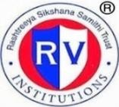 | RASHTREEYA SIKSHANA SAMITHI TRUST  R V INSTITUTE OF MANAGEMENT  CA 17, 26 Main, 36th Cross, 4th T Block, Jayanagar, Bengaluru, Karnataka 560 041 | 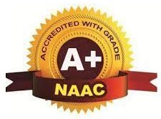

Internal Quality Assurance Cell

Minutes of the Meeting

A quarterly meeting of IQAC members was held on 13th August, 2022 from 11.00 am to 12.30 pm to discuss the following agenda:

- Approval of the minutes along with the Action Taken Report of the meeting held on 13th August 2022
- To brief the members about the seamless conduct of II Sem examinations for the first autonomous 2021-23 Batch and the results
- To brief the members about the admissions for 2022-24 Batch
- To brief the members about the disbursement of scholarships to the Academic Achievers of the first autonomous batch 2021-23
- To brief the members about the statutory body meetings conducted during 2022-23
- To discuss about the Infrastructure enhancement in the Institution
- To discuss about the new quality initiatives adopted by the institute.
- To present the details regarding the achievements- students, Faculty & Institutional.
- To present the details regarding programmes/ events organized in the Institute during the previous quarter and the way forward.
- To seek suggestions from the members regarding continuous quality improvement.
Any other issues with the permission of the chair

The meeting was presided over by the Dr. Purushottam Bung, Chairman, IQAC, and the following members were present in the meeting.
- Dr. N.S.Narahari
- Mr Gururaj Deshpande
- Mr M V Srinivasa
- Dr. Anupama K Malagi
- Prof. N Nagasubba Reddy
- Dr Padmalini Singh
- Dr Santhosh M
- Dr Noor Firdoos Jahan
- Dr Jahnavi M
- Ms Payal Jindal
- Ms. Anupama S M
- Mr. Chethan Kumar
- Mr Vamsi Krishna
- Ms. Sahana M S

Proceedings
IQAC meeting commenced with welcome address by Dr. Anupama K Malagi, Convenor IQAC. At the outset the Chairman welcomed all the members for IQAC quarterly meeting.

- Reading and Approval of the minutes of the meeting held on 30th April 2022
Dr. Anupama K Malagi convenor of IQAC presented the minutes of the previous meeting and action taken report. All the members approved as no objection or comments were received.

- To brief the members about the seamless conduct of examinations for the first autonomous 2021-23 Batch and the results

The IQAC Convenor was happy to share the details about the seamless conduct of examinations for the first autonomous batch , the details of which are presented below:
For the first autonomous batch, End Semester Examinations were conducted from 21.5.20222 to 8.6.2022. The SEE included both Theory and Practical Examinations.
All the answer scripts were subjected to TWO valuations. Each answer script was valued by Internal Examiner (Faculty of RVIM) and External Examiner.
The final marks for each student was calculated on the basis of the average of two valuations. The deviations between the first and second valuation more than 20 marks was subjected to Third valuation. The marks awarded by the valuator of third valuation is final.
Results were announced within a span of One Month

Summary of Results
Sl. No | Details | No. of Students | Percentage
1 | No. of Students Appeared | 180
2 | No. of Students passed | 142 | 78.88
3 | No. of Students Failed | 38 | 21.12

Result Analysis

Sl. No | Details | No. of Students
1 | First Class with Exemplary | 10
2 | First class with Distinction –A | 87
3 | First Class- B+ | 43
4 | High Second class | 02
5 | Second Class- B | -
6 | Pass class | -
7 | Fail | 38
 | Total | 180

TOPPERS
Sl. No | Name of the student | Marks obtained | S.G.P.A/CGPA
1 | SRUJANA S | 228/27 | 8.44
2 | CHAITANYA KAMATAGI B | 226.5/27 | 8.39
3 | MADHURA A | 223.5/27 | 8.28
4 | SAGI SAMPI | 221.5/27 | 8.20
5 | PRAMOD K L | 219.5/27 | 8.13

- To brief the members about the disbursement of scholarships to the qualified students of the first autonomous batch 2021-23 and increase in the number of scholarships:

The IQAC Convenor was happy to share the details about the disbursement of scholarships:

Scholarships successfully disbursed to the top ten rank holders in the PGCET ( within top 100 ranks ). Same extended to the II year also for the top ten performers in I year SEE ( Above 7.0 CGPA)- 2021-23 Batch

Management has approved for the scholarships to the top 15 rank holders in PGCET ( within top 100 ranks). Same extended to the II year for the top 15 performers in I year SEE ( Above 7.0 CGPA)- 2022-24 Batch

The members appreciated the initiative and also suggested to try for sponsorships to recognise top performers in academic & non-academic fields.

- To brief the members about the formation of RAC and conduct of the first meeting

The details about the composition of RAC and also proceedings of the first meeting were shared with the members:

The proceedings of the Finance Committee Meeting were shared with the members of IQAC. The Chairman of IQAC was happy to inform the members about the merit scholarship that was disbursed to the top ten rankers among the top 100 PGCET ranks and also about the scholarships for the top 10 performers in the II Year.(2021-23 Batch)
Announcement of merit scholarship of Rs 50,000/- (as tuition fee waiver for I Year) to top 15 rankers (within 100th Rank) and Academic Achievement Scholarship of Rs 50,000/- ( as tuition fee waiver for II Year) was also informed to the IQAC.
The members appreciated the initiative and further suggested that scholarships need not be restricted only to academics. Rather, students’ achievements in extracurricular activities also can be considered for the same. Out of 15, 1 scholarship can be earmarked for sports category and 1 for extra curricular achievement.

- To brief the members about the forthcoming statutory body meeting scheduled in June/July 2022
The convenor of the IQAC was happy to share the schedule for the forthcoming meetings of the statutory bodies, the details of which are as follows:
Board of Studies meeting- June- July 2022
Academic Council Meeting- June- July 2022
Governing Body Meeting- July- August 2022

- To discuss about the Infrastructure enhancement in the Institution
The Chairman of IQAC was happy to inform the members that infrastructure enhancement work is in progress to renovate the computer labs. The labs will be of best-in- class standards and 40 new i7 11th Gen computers have also been procured. The existing 140 systems will be upgraded with SSD Drives to boost the speed. The IQAC and Library will also be renovated soon.
The members of IQAC appreciated the efforts of the Institution.

- To discuss about the new quality initiatives adopted by the institute
The convenor was happy to share the details about the new quality initiatives adopted by the institute during the last quarter. The details are as follows:

- GENESIS-2021 : GENESIS 2021-22, Inauguration of first Autonomous Batch on 27th January 2022, Seminar Hall, RVIM from 10.00am onwards . It began with a positive affirmation that ‘A beautiful day begins with a beautiful mindset’. The event was graced by the presence of Chief Guest Dr. Rishikesha T Krishnan, Sri Shesh Rao Paplikar, Sri Sujit Chandan K A and Presided by Sri P N Praveen on. Students were formally welcomed and introduced to the culture of the campus and the college.
The journey of I year MBA unfolded on 27th January 2022, the day started with a warm welcome from our Director, teachers and the students of II year MBA and it was followed by a week of exuberant learning on diverse management skills.
- ORIENTATION :
Insecurities and uncertainties are always in our mind when we begin walking on a new path. To ease this tension and anxiety for the new incoming batch, a week long orientation programme was organized. Through the course of the program the students were introduced to the life at the center which revolves around an array of activities alongside studies, researches, community services and many more. The main aim of the Orientation Programme is to help them understand the values, ethics and culture of the college and to showcase the myriad academic and co-curricular learning opportunities the college provides.
This orientation program highlighted to the students that learning in RVIM is not restricted to classroom studies rather they are encouraged to take part in various activities in college and also outside college to hone their skills and emerge as the best version of themselves by providing various opportunities and skill sets which shapes them for a bright future ahead.
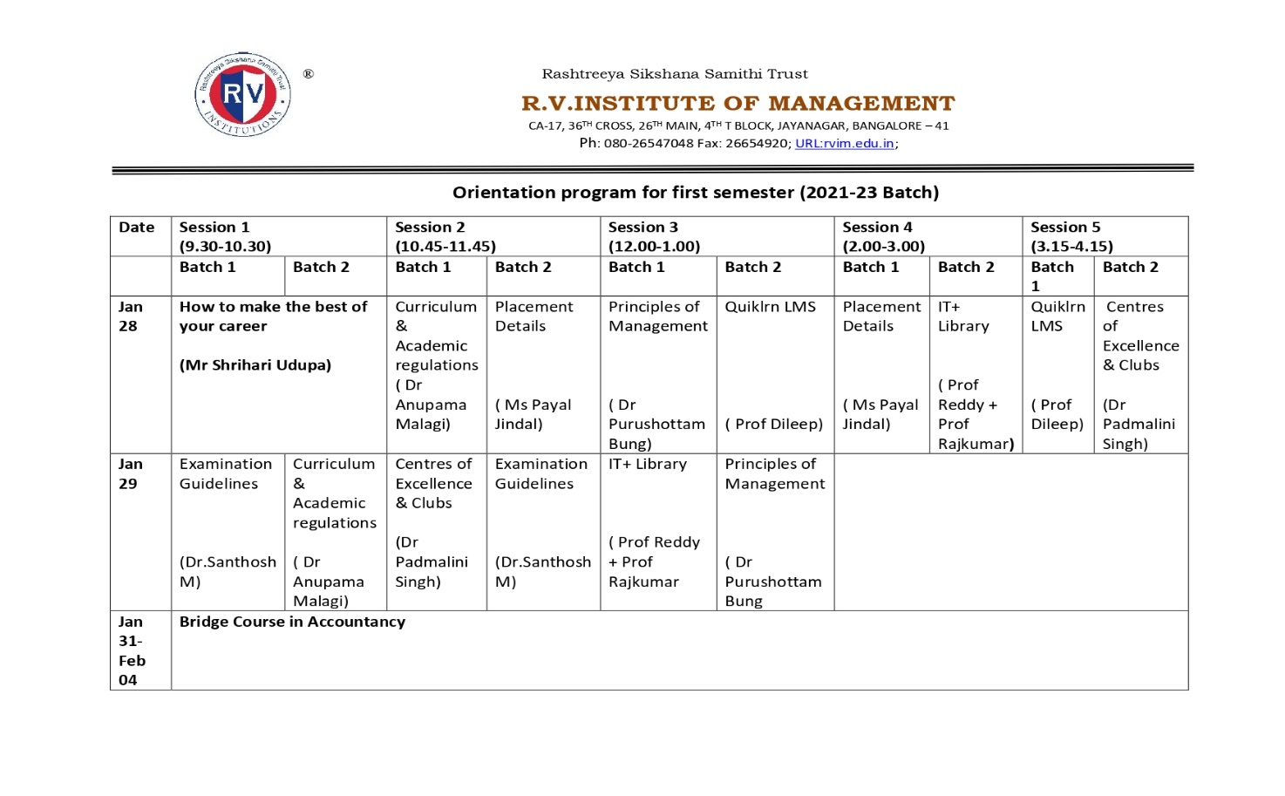

- PARTNERING WITH COURSERA
GRAND LAUNCH
On April 13th, 2022, RVIM officially launched Coursera for Campus in collaboration with Coursera
Students were given access to over 5000+ courses. Students will be able to expand their skill sets by taking a variety of courses relevant to the ever-changing market environment as a result of Coursera's partnership with RVIM. This aids students in learning job-related abilities that companies seek.
The grand launch of Coursera for Campus took place in the presence of Dr. Purushottam Bung, Director, RVIM; Bibin Shivas, Head of Customer Success, APAC, Coursera; Shubhangi Sood, Customer Success Manager, Coursera; and Shikha Sharma, Sr. Implementation Manager, APAC, Coursera.
- MoU with EWOL-U for International Collaborations for Strengthening International Collaborations aimed at international immersions, faculty development programs, student development programs, etc
- Research Promotion Policy
The chairman of IQAC was happy to share with the members that we are proposing to start our own Ph.D programme for which the draft guidelines have already been prepared. The guidelines were placed before the IQAC to seek suggestions from the members.
In this context, the new policy which was framed to incentivize and promote Research- Consultancy- Extension efforts of the Institution was shared with the IQAC members. The policy was approved by the management and will be in force from 01.04.2022.The IQAC members appreciated the efforts of the Research Centre.

- To present the details regarding programmes organized in the Institute during the previous quarter and the way forward.
The IQAC Convenor was happy to present the list of all the events/ activities organized during the previous quarter. The activities were pertaining to student development & faculty development. The details of the activities are presented as follows:

SI.No | Date | Events/Activity Organized |  | Resource Person/Designation
1 | 12th December 2021 | Central Vigilance Commission Activity on Integrity Pledge |  | Dr A.N Yallapa Reddy and Dr Purushottam Bung
2 | 17th December 2021 | Ek Bharath Shretha Bharath -AICTE Initiative on Uttarakhand tourism activity |  | Dr Purushottam Bung
3 | 30th December 2021 | Importance and Usage of Credit Cards |  | Mr. Pardeep Kumar
4 | 5th to 9th January 2022 | 10 Hours Certificate Course On Financial Education For Young Citizens (Kona Kona Siksha) In Association Kotak Bank And Nism |  | Dr Sarika Lohana
6 | 12th January 2022 | Swami Vivekananda Jayanthi Celebration |  | Dr Suresh N
7 | 26th January 2022 | Republic Day Celebration |  | Air Marshall H.B Rajaram
8 | 21st February 2022 | Matribhasha Diwas - International Language Day |  | Mr Shashidhar Kote
9 | 28th February 2022 | Union Budget Presentation Analysis -2022 |  | Dr Pushkarni Panchamukhi , R V University
10 | 23rd February 2022 | Financial Literacy Awareness Program by N.J Group |  | Ms Neetu Choudhary
11 | 1st December, 2022 | Business marketing- Guest lecture |  | Mr. Vikas VB, Marketing & Sell Out Co-ordinator, Bosch & Siemens Home Appliances – Karnataka.
12 | 19th, 20th and 22nd January 2022 | Three days workshop on 'Dimensions of Sustainability in Business' |  | Vijetha Shastry, Executive Director TiE Bangalore., Bengaluru
13 | 24th to 25th January, 2022 | Online Management Development Programme on “Role of Business in Sustainable Development” |  | Dr. Naresh Tyagi,  Chief Sustainability Officer,  Aditya Birla Fashion and Retail, Bengaluru  Dr. Lalitha Ramakrishnan  Professor, Department of Management Studies,  Pondicherry University, Puducherry  Prof. Charan Singh  CEO and Director,  EGROW Foundation, NOIDA  Dr. Purushottam Bung, Director, RVIM
14 | 6th and 7th Jan, 2022 | Webinar Talk on “Neuroscience and its application” |  | Dr Naveen G Halappa, Senior Assistant Professor, School of Public Health and School of Buddhist Studies, Philosophy and Comparative Religions (SPH/SBSPCR), Nalanda University
15 | 18th November, 2021 | ICPR sponsored Webinar on 'Basic values embodied in Indian Culture and their relevance to National Reconstruction' |  | Dr. Pawan Kumar Singh, Director, IIM Trichy
16 | 18th January, 2022 | ICPR sponsored Webinar on 'Social and Political philosophy' |  | Dr. Jose Nandhikkara, Professor of Philosophy at Dharmaram Vidya Kshetram and Christ University, Bangalore.
17 | 12th March, 2022 | ICPR sponsored webinar on 'Ethics of Globalization" |  | Dr. Subhash Sharma, Director, IBA, Bangalore
18 | 1st Jan - 31 st Jan 2022 | Certificate course on Introduction to Machine Leanrning using Python |  | Mr.Aditya Gose
19 | 11 – 12 January 2022 | Workshop On Application of Machine Learning Algorithms Using R |  | Ms. Chandrika P V,  Department of Research & Business Analytics,  Welingkar Institute of Management Studies, Mumbai
20 | November 2021-December 2021 | Cerfication course on E-commerce |  | Mr. Sameer Muthalik Desai
21 | 4th December 2021 | Meet the executive by Vikas V B |  | Mr. Vikas(Alumni)
22 | 21st January 2022 & 4th Jan 2022 | Meet the executive by Channakeshave Hegde | Mr. Channakeshav Hegde(Alumni)
23 | 12th february 2022 | Meet the executive by Jayanth Hiremath | Mr. Jayanth Hiremath(alumni)
24 | 5th February 2022 | Meet the executive by Mr. Chandramouli | Mr. Chandramouli
25 | 26th February 2022 | Meet the executive by Mr. Simhadri Rama Rao | Mr. Simhadri Rama Rao
26 | 10th Jan 2022 - 4th Feb 2022 | ITTC- Corporate Tax | Prof. Dileep
27 | 21st Feb 2022 - Ongoing | ITTC - Partnership Taxation | Prof. Pooja Takalkar
28 | 18th Feb 2022 - Ongoing | ITTC - Power Bi | Prof. Nagasubba Reddy
29 | 29th January 2022 | Meet the executive by Ms. Linu from ITC | Ms. Linu
30 | 7th December, 2021 | Green Crew- Environment quiz | Dr. Yellappa Reddy, Governing council member of foundation for ecological security of India.
31 | 21st January 2022 | Meet the executive | Mr. Channakeshav Hegde(Alumni)
32 | 12th February 2022 | Meet the executive | Mr. Jayanth Hiremath(alumni)
33 | 8th March 2022 | Self Defence- Activity | Mr. Menkiyo Kaiden and Mr. Ramesh Jodige
34 | 8th March 2022 | Drama competition - Women Empowerment | Judges- Mr. Vikas VB and Ms. Supradha
35 | 8th March 2022 | Women's Day Panel Discussion | Chief Guest- Rtn Udayabhaskar Panelists- Dr Akkai Padmashali, Dr Pallavi, Ms Maya Chandra, Ms Uma Reddy, Ms Najma Farooqi
36 | 27th Jan 2022 | Genesis 2021- Inauguration of 2021-23 Batch of MBA | Chief Guests- Dr Rishikesha T Krishnan, Director, IIMB, & Mr Shesha Rao Paplikar, Founder CEO of BEEHIVE
37 | 13th Nov 2021 | Graduation Day for 2018-20 & 2019-21 Batch | Chief Guests- Dr Augustus Azariah & Prof J R Sharma
38 | 8th March 2022 | Self Defense- Activity | Mr. Menkiyo Kaiden and Mr. Ramesh Jodige
39 | 22nd April, 2022 | Workshop on Emotional Intelligence  Workplace Engagement & Being Productive | Ms Arpitha Ranganath  Mr Aravind Warrier
40 | 21st April, 2022 | Workshop on Data Analysis using Excel & SPSS and Data representation using Tableau | Mr Sathish Kumar S
41 | 26th April, 2022 | NCW Sponsored Webinar on “Capacity Building and Personality Development” | Dr. Purushottam Bung, Director, RVIM  Dr. Rizwana M, Assoictae Professor, RIT  Dr. Padmalini Singh, Associate Professor, RVIM
42 | 26th April 22 | Awareness of IPR | Prof. Chandran A
43 | 27th April, 2022 | Workshop on Emerging trends in Marketing | Mr. Venkatesh Majji
44 | November 2021-December 2021 | Cerfication course on E-commerce | Mr. Sameer Muthalik Desai
45 | 4th December 2021 | Meet the executive by Vikas V B | Mr. Vikas(Alumni), Sales Officer, Seimens
46 | 21st January 2022 & 4th Jan 2022 | Meet the executive by Channakeshave Hegde | Mr. Channakeshav Hegde(Alumni), VP HSBC
47 | 12th February 2022 | Meet the executive by Jayanth Hiremath | Mr. Jayanth Hiremath(alumni), TA, Flipkart
48 | 20th November 2021 | Meet the executive by Dr. Sharan Shetty | Dr. Sharan Shetty
49 | 5th February 2022 | Meet the executive by Mr. Chandramouli | Mr. Chandramouli, HR L&D Abylle Solutions Pvt. Ltd.
50 | 5th March 2022 | Meet the executive by Mr. Chandramouli | Mr. Chandramouli, HR L&D Abylle Solutions Pvt. Ltd.
51 | 26th February 2022 | Meet the executive by Mr. Simhadri Rama Rao | Mr. Simhadri Rama Rao L&D , Amazon
52 | 10th Jan 2022 - 4th Feb 2022 | ITTC- Corporate Tax | Prof. Dileep
53 | 18th Feb 2022 | ITTC - Power Bi | Prof. Nagasubba Reddy
54 | 29th January 2022 | Meet the executive by Ms. Linu from ITC | Ms. Linu, South Head HR, ITC
55 | 18th December 2021 | Meet the executive by Mr. Rakesh Arakere | Mr. Rakesh Arakere, CFO. TaeguTec India Private Ltd
56 | 11th Decemebr 2021 | Meet the executive by Dr. Goutami Sudhakar | Dr. Gowtami Sudhakar,Head Personal and General Administration, Propellant Complex
57 | 22nd April 2022 | Workshop on Emotional Intelligence | Ms.Arpitha ,EQ Practioner
58 | 22nd April 2022 | Workshop on Work place Engagement and Being Productive | Mr. Arvind Warrier, Sr. Manager HR, RapidValue Solutions
59 | 12th and 13th Decemenber 2021 | Student Development Program on Interview Process and Current Demand in the market, Holistic Approach for team building activities | Mr. Manikanta Namburi, TA, Odessa Solutions
60 | 22nd March 2022 | Workshop on Effective Communication for Negotiations | Ms. Beena, Trainer

- To seek suggestions from the members regarding continuous quality improvement.
The members gave the following valuable suggestions:
- Undertaking from students should be taken for the proof that they have read the Code of Conduct in the Student Handbook.
- Human Computer Interaction Course should be offered to the students along with the Design Thinking Course. Such courses are available on various platforms including Coursera.
- The calendar planning should be done for MOOC courses to ensure smooth completion of the course.
- Documentation proof should be prepared for keeping the records of MOOC courses along with the certificate.
- 40% weightage to pass coursera course should be raised keeping in mind the qualitative and quantitative courses selected by the students.
- Coursera course scores may be considered for total marks but may not be considered for CGPA to balance between qualitative and quantitative courses completed by the students.
- Scholarship may also be offered in categories such as non-academic/extra-curricular activities (sports/music/dance/theater etc.,) to those students who participate on major competition on Regional, National and International Level.
- The scholarship should be offered by setting the criteria that the scholarship will be awarded only in II year to the students to ensure that they participate in extra-curricular on a regular basis.
- A separate block for Hostel facility for Boys and Girls should be provided in close proximity to the college managed completely by the Institution.

- Any other matter with the permission of the chair:
There being no other issues discussed during the meeting, Dr. Anupama K Malagi proposed Vote of thanks. She expressed her sincere gratitude and thanked all the IQAC members for their great support and contributing to the healthy discussion related to various aspects of quality initiatives in the institute.

Director & Chairman IQAC IQAC Convenor

