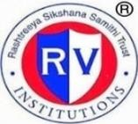 | RASHTREEYA SIKSHANA SAMITHI TRUST  R V INSTITUTE OF MANAGEMENT  CA 17, 26 Main, 36th Cross, 4th T Block, Jayanagar, Bengaluru, Karnataka 560 041 | 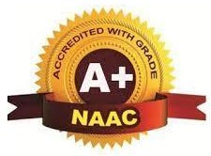

Internal Quality Assurance Cell

Minutes of the Meeting

A quarterly meeting of IQAC members was held on 13th April, 2023 from 4.00 pm to 5.30 pm to discuss the following agenda:

- Approval of the minutes along with the Action Taken Report of the meeting held on 13th August 2022
- To brief the members about the seamless conduct of II Sem examinations for the first autonomous 2021-23 Batch and the results
- To brief the members about the admissions for 2022-24 Batch
- To brief the members about the disbursement of scholarships to the Academic Achievers of the first autonomous batch 2021-23
- To brief the members about the statutory body meetings conducted during 2022-23
- To discuss about the Infrastructure enhancement in the Institution
- To discuss about the new quality initiatives adopted by the institute.
- To present the details regarding the achievements- students, Faculty & Institutional.
- To present the details regarding programmes/ events organized in the Institute during the previous quarter and the way forward.
- To seek suggestions from the members regarding continuous quality improvement.
- Any other issues with the permission of the chair

The meeting was presided over by the Dr. Purushottam Bung, Chairman, IQAC, and the following members were present in the meeting.
- Dr. N.S.Narahari
- Dr Sen B Mathews
- Mr Chandramouli
- Dr. Anupama K Malagi
- Prof. N Nagasubba Reddy
- Dr Tamizharasi D
- Dr Santhosh M
- Dr Jahnavi M
- Dr Vinay K S
- Ms Payal Jindal
- Ms. Anupama S M
- Mr. Chethan Kumar
- Mr Vamsi Krishna
- Ms. Vibha S Bhat
- Mr Anushruth D

Proceedings
IQAC meeting commenced with welcome address by Dr. Anupama K Malagi, Convenor IQAC. At the outset the Chairman welcomed all the following new members for IQAC quarterly meeting
1. Dr Sen Mathews, Director, Employability & Corporate Relations, Kristu Jayanti College- Member from Academia
2. Mr Chandramouli, Head HR, Abylle Solutions, Bengaluru- Member from Industry
3. Ms Bindu Elakkal, Bren Technologies, Bengaluru- Parent Representative
4. Dr Tamizharasi D, Professor, RVIM
5. Dr Vinay K S, Assistant Professor, RVIM
6. Ms Vibha S Bhat, I Sem MBA- Student Representative
7. Mr Anushruth D- I Sem MBA- Student Representative
He also thanked all following members who left IQAC:
- Mr Gururaj Deshpande
- Dr Sudha Rao
- Mr M V Srinivasa
- Ms Sahana M S
- Mr Rahul Yelavatti

- Reading and Approval of the minutes of the meeting held on 13th August 2022
Dr. Anupama K Malagi convenor of IQAC presented the minutes of the previous meeting and action taken report. All the members approved as no objection or comments were received.
Sl. No. | Suggestions | Action taken
1 | To try for sponsorships for recognising top performers- both academic & non-academic | Approached few organisations through our alumni network- discussions are in progress
2 | Faculty members to nurture the connection established during BIP | All faculty mentors compulsorily visiting the organisations during BIP has resulted in strengthening the association- Industry –Institute Interaction sessions are more frequent & effective
3 | To offer PG Diploma programmes by virtue of being autonomous | Curriculum framework and guidelines prepared for the PG Diploma in Business Analytics and got the approval of the statutory bodies.
4 | Best BIP reports, top scorers in Health & Wellness to be rewarded | Top scorers in BIP and Health & Wellness were honoured during the Inauguration of the new batch during February 2023.
5 | Effective implementation of Social Immersion Programme | Total number of NGOs in which our students carried out the SIP is close to 100. Top scorers in SIP will be rewarded during the next inaugural ceremony
6 | Increase the number of scholarships | Management increased the number of scholarships from 10 to 15 for I Year( Top Scorers in PGCET)& II Year ( Top academic performers in I Year) from 2022-24 Batch onwards.

2. To brief the members about the seamless conduct of II Sem examinations for the first
autonomous 2021-23 Batch and the results

The COE shared the details about the seamless conduct of II Sem examinations for the first autonomous batch , the details of which are presented below:
For the first autonomous batch, End Semester Examinations of II Sem were conducted from 21.11.2022 to 19.12.2022. The SEE included both Theory and Practical Examinations.
All the answer scripts were subjected to TWO valuations. Each answer script was valued by Internal Examiner (Faculty of RVIM) and External Examiner.
Valuation Summary:
- Number of Scripts for First valuation = 1246
- Number of Scripts for Second valuation = 1246
- No. of Scripts for Third valuation = 45
- Total No. of Scripts valued = 2537
- No. of Evaluators: Internal = 13, External =12, Total = 25
- No. of days of valuation = 21 days
- Average No. of scripts valued per day = 121

Summary of Results

Sl. No | Details | No. of Students | Percentage
1 | No. of Students Appeared | 179
2 | No. of Students passed | 144 | 80.45%
3 | No. of Students Failed | 35 | 19.55%

Result Analysis

Sl. No | Details | No. of Students
1 | First Class with Exemplary | 32
2 | First class with Distinction –A | 98
3 | First Class- B+ | 14
4 | High Second class | -
5 | Second Class- B | -
6 | Pass class | -
7 | Fail | 35
 | Total | 179

TOPPERS
Sl. No | Name of the student | Total Grade Points | S.G.P.A/CGPA
1 | CHAITANYA KAMATAGI B | 282 | 8.81
2 | NIVEDITHA K SWAMY | 278 | 8.69
3 | SAGI SAMPI | 277.5 | 8.67
4 | VAISHNAVI N | 277 | 8.66
5 | PRAJWALA | 273 | 8.53
6 | RAMANABOINA ANAND KUMAR | 271.6 | 8.48
7 | SHUBHA R | 268.5 | 8.39
8 | MADHURA A | 267.5 | 8.36
9 | SRUJANA S | 267.5 | 8.36
10 | POORNIMA L | 265 | 8.28

3. To brief the members about the admissions for 2022-24 Batch:
Admissions Summary:
Year | Intake | Total students admitted | Students from other states | PGCET first round GM cut-off | Reconciliation seats | Gender Split  Boys | Girls
2017-18 | 180 | 172 | 19 | 731 | - 25 | 102 | 70
2018-19 | 180 | 180 | 21 | 517 | + 4 | 118 | 62
2019-20 | 180 | 180 | 23 | 461 | + 8 | 93 | 87
2020-21 | 180 | 180 | 19 | 417 | + 12 | 98 | 82
2021-22 | 180 | 180 | 28 | 336 | +10 | 107 | 73
2022 -23 | 180 | 180 | 17 | 214 | + 4 | 116 | 64

Current autonomous batch status:
- Started the batch on 01.02.2023
- Completed MID SEMESTER EXAMS recently
- Planning to conduct final semester end exams during 22.05.2023 to 12.06.2023
- Business Immersion will happen during 19.06.2023 to 29.07.2023

4. To brief the members about the disbursement of scholarships to the qualified students of the first autonomous batch 2021-23
The following top 10 Academic Performers received scholarship of Rs 50,000/- during the inauguration of the new batch on 01.02.2023

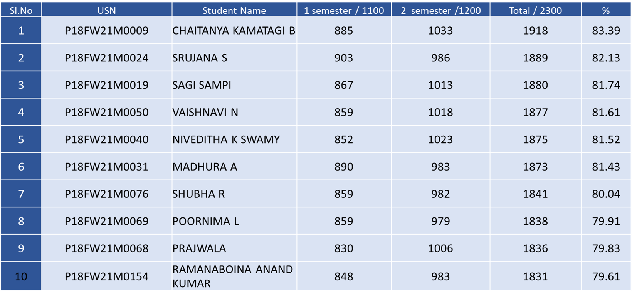

Recognition certificate along with cash prize of Rs 5000/- were successfully disbursed to the top performers in Health & Wellness and Business Immersion( Above 7.0 CGPA) as well for 2021-23 Batch

TOP Scorer details
Sl.no | Reg.no | Name | CIA | SEE | Marks/100 | %
Health & Wellness – 21MBA823
1 | P18FW21M0096 | B SHASHANK | 48 | 43 | 91 | 91%
Business Immersion – 21MBA821
1 | P18FW21M0140 | YASHWANTH R | 42 | 48 | 90 | 90%
2 | P18FW21M0179 | SAAHIL SRIKANT KULLOLI | 46 | 44 | 90 | 90%

5. To brief the members about the statutory body meetings conducted during 2022-23
The meetings were held as follows:
Board of Studies meeting- 06.12.2022
Academic Council Meeting- 19.12.2022
Finance Committee Meeting- 29.12.2022
Governing Body Meeting- 09.01.2023
The important discussions during the meeting:
- Governing Body approval of the curriculum framework, academic regulations, guidelines and detailed syllabi of the PGDBA Programme recommended by BoS, ratified by the AC and accepted by FC.
- Governing Body approval of the academic regulations, guidelines and Syllabi for course work for the Ph.D Programme, recommended by BoS , ratified by Academic Council and accepted by Finance Committee.
- Governing Body approval of the provision for fast track semester with examinations from the next academic year

6. To brief the members about the Infrastructure enhancement in the Institution

The IQAC convenor briefed the members about the infrastructure enhancement happened in the institution post last IQAC meeting:

- Refurbishment of IQAC & Centre for Research & Consultancy
- Refurbishment of Centre for Wellness
- Setting up of Centre for Peace and Yoga

7. To discuss about the new quality initiatives adopted by the institute:
The convenor was happy to present before the members about the various quality initiatives adopted by the institute:

- Launching of certificate course in Predictive Analytics using R in association with Boston IT Solutions India Pvt Ltd. The duration is 2 months including Capstone Project
- Institutional funding for research proposals wherein faculty members are encouraged to submit minor research proposals for a duration of six months and research grants will be sanctioned to those proposals which are approved by the RAC.
- Collaboration with NSMART to get exposure to stock trading. Accordingly, 33 licenses were subscribed. Students can trade in a simulated environment with virtual currency and create their own portfolio.
- Regular industrial & institutional visits organized – Visit to IKEA, IIMB, IISc, Labour Commissioners Office, etc
- Successfully completed Social Immersion Programme for II Sem students
- Successfully completed Domain Specific Skill course by Mentor Mind- which helped in students working on real time projects from companies called Menternships. MOU has been executed with Mentor Mind
- Domain specific skill course enriched by offering one week workshops on ‘Applications of AI & ML’ in the various functional domains like HR, Marketing & Finance
- Students have completed minimum 3 courses maximum of 5 courses on Coursera platform as part of open electives
- Institution has become life time member of BMA so as to facilitate conducting major events
- One Day FDP by Talent Matrix and Five faculty members got CBMA certification
- Encouraging students to present and publish their papers ( from SIP and BIP) in National and International conferences. So far, around 12 students have presented their papers.
- Institution has become Associate Centre of Indian Yoga Association
- Institution has become life member of Analytics Society of India, IIMB
- Recognition of faculty and student champions by QUIKLRN LMS for maximum usage of the platform
- Working on launching on 2 certificate courses – Story telling and Data Visualisation using Tableau and Machine Learning using Python in the upcoming quarter.
- Planning to offer Outbound training programs to the 1st Sem students as part of Principles of Management

8. To present the details regarding the institutional achievements:
The IQAC Convenor was happy to present the institutional achievements to the members:

- Update on Placements
Particulars | 2020-22 | 2021-23  (Ongoing)
Total no. of companies (on/off campus) | 70 | 43
Total no. of students | 177 | 178
No. of students not opted for placements | 11 | 2
Total no. of students opted for placements | 167 | 176
No. of students placed | 154 | 130
Effective % of placements | 92% | 74%
Maximum CTC offered | 12.59L/A | 13.56L/A
Median Package | 6L/A | 6.2L/A

- Conferred with Diamond Rating in the Subject Rating Category by QS I Gauge Global Ranking Agency during Nov 2022.
- RVIM Received award from Hon’ble Governor of Karnataka Shri Thawarchand Ghelot as ‘the best private management institution for Industry Interface for its contribution in Education, Skill development and Research’ during the 19th Rashtriya Shiksha Gaurav Puraskar Ceremony 2022.
- RVIM was recognised with the Higher Education – Jury Award as one of the ‘TOP B-Schools of the 50 best Private B-Schools, Jury Awards’ on 11th October, 2022

9. To present the details regarding programmes organized in the Institute during the previous quarter and the way forward.

The convenor was happy to present the details of 65 programs/events organised in the institute including seminars, workshops, certification courses, guest lectures, etc.
The members were happy to note the details of major events organised –
- Graduation Day for the 2020-22 Batch
- Guruvandana Programme in association with Pranav Foundation
- Genesis 2022- Inauguration of the new batch of MBA ( 2022-24 Batch)
- Womens Day Programme
- Venture Fest
- SEE Doctoral Colloquium

10. To seek suggestions from the members regarding continuous quality improvement

- Regarding the Social Immersion Program, members suggested to tie up with social welfare organizations/Government of Karnataka promoting SDGs to enhance the visibility in the eyes of government which will help us to improve SIP outcomes in a better way
- It was also suggested to work on with one of the sustainable goal for the betterment of society as a part of SIP from the institution.
- Members advised to build rapport with government and try to get projects of social concern.

- The members appreciated the initiative of NSMART subscription where students can indulge in mock stock trading and create their own portfolio and learn. This platform builds confidence among students and prepares them for bright careers in Investment Consulting.
- The members suggested to organize one week induction program to first semester students. This program should contain sessions on Life skills and people skills.
- The members appreciated the various activities/ events organised by the Institute

11. Any other matter with the permission of the chair:
There being no any other issues to be discussed during the meeting, Dr. Anupama K Malagi proposed Vote of thanks. She expressed her sincere gratitude and thanked all the IQAC members for their support and contributing to the healthy discussion related to various aspects of quality initiatives in the institute.

Director & Chairman IQAC IQAC Convenor

