Institution Code of Conduct Committee

The following members would continue to serve on the Institution Code of Conduct for the year 2024-25 –

1. Dr Purushottam Bung, Professor and Director, RVIM
2. Dr Anupama K Malagi, Professor, RVIM
3. Dr Rashmi Shetty, Assistant professor, RVIM
4. Mr Manjunath S K, Assistant professor, RVIM

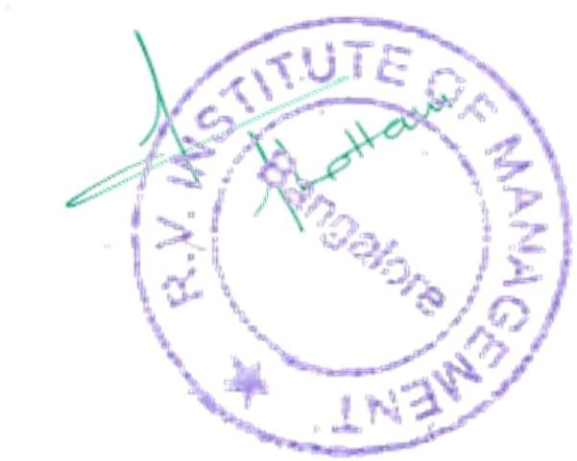





Director
CA 17, 36th Cross Rd, 26th Main, 4th T Block East
Bengaluru - 560041, Karnataka, India
080 42540300
080 26547048
www.rvim.edu.in
Scan Here

