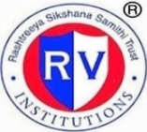 | RASHTREEYA SIKSHANA SAMITHI TRUST  R V INSTITUTE OF MANAGEMENT  CA 17, 26 Main, 36th Cross, 4th T Block, Jayanagar  Bengaluru, Karnataka 560 041 | 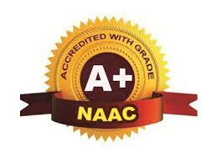

7.1.3 -Describe the facilities in the Institution for the management of the following types of degradable and non-degradable waste
Waste Management System in the Institution:
- Solid Waste Management System:- Paper and other waste from campus is collected in the collection bins and disposed through the City Municipality Corporation collection vans. The assigned housekeeping staff takes charge of collecting and disposing the solid waste.
- STP –Liquid Waste Treatment Plant –an in-house STP system is installed, with a capacity of 20 kld.
- E-Waste management- ITC is the listed vendor. E-waste is disposed through the vendor on a monthly basis.
Waste Management Practices in the Institution:
Waste Management and disposing waste appropriately is practiced at the institution
Instruction to Students and Staff on disposing the waste in designated dustbins is given through display boards and reminders on maintaining cleanliness in class rooms and campus. Designated dust bin for dry and wet waste are put in the corridors, class room and the wash rooms on all three floors of the college, display play boards gives instruction to students and staff to dispose the waste in the dustbins
The Group D staff is in charge of waste clearing and colleting from the campus. The housekeeping staff are trained to manage the waste. Display boards are put up to inform of appropriate waste disposal behaviour within the campus.
Students and Faculty take part in Clean Campus drive in association with WoW ITC the campus is audited for waste generated and that audit result are used make better guidelines to reduce waste on campus by educating and building awareness in the campus.

